

**UNIVERSITY OF GHANA LEGON**

**DEPARTMENT OF COMPUTER ENGINEERING**

SCHOOL OF ENGINEERING SCIENCES

**FINAL YEAR PROJECT REPORT**

ON

**DETECTION AND CLASSIFICATION OF MENTAL HEALTH DISORDERS USING MACHINE LEARNING**

PROJECT REPORT SUBMITTED IN PARTIAL FULFILMENT OF THE REQUIREMENTS FOR THE BACHELOR OF SCIENCE DEGREE IN COMPUTER ENGINEERING

NAME OF STUDENTS: ELLIS OPARE-OSABUTEY - 10895794

ATO MENSAH NYAMEKYE - 10867736

FELIX BOACHIE-YIADOM - 10885671

NAME OF SUPERVISOR: DR. GODFREY MILLS

CO-SUPERVISOR: PROF. ELSIE EFFAH KAUFMANN

DATE OF SUBMISSION: 13th September,2024

**Detection and Classification of Mental health disorders using machine learning**

By

ELLIS OPARE-OSABUTEY 10895794

ATO NYAMEKYE MENSAH 10867736

FELIX BOACHIE-YIADOM 10885671

Submitted to the Department of Computer Engineering in Partial Fulfilment of the Requirement for the Degree of Bachelor of Science in Computer Engineering University of Ghana

Date: 13th September,2024

Name of Student: ELLIS OPARE-OSABUTEY

Signature of Student:_______________________________________

Name of Student: ATO NYAMEKYE MENSAH

Signature of Student:_______________________________________

Name of Student: FELIX BOACHIE-YIADOM

Signature of Student:_______________________________________

Name of Supervisor: DR. GODFREY MILLS

Signature of Supervisor:_________________________________

Name of Co-Supervisor: PROF. ELSIE EFFAH KAUFMANN

Signature of Supervisor:_________________________________

Name of Head of Department:____________________________

Signature of Head of Department:_________________________

**Declaration of Originality**

Department of Computer Engineering

I certify that the content of this thesis document is my own work except where indicated by referencing. I confirm that I have read and understood the guidelines on plagiarism in the Computer Engineering Undergraduate Thesis Handbook including the University of Ghana’s policy on plagiarism. I have acknowledged in the text of this document all sources used. I have also referenced all relevant texts, figures, data, and tables quoted from books, journals, articles, reports, Internet websites, and works of other people. I certify that I have not used the services of any professional person or agency to produce this thesis document. I have also not presented the work of any student present or past from other academic or research Institutions. I understand that any false claim in respect of this thesis document will result in disciplinary action in accordance with regulations of the University of Ghana.

Please complete the information below by Hand and in BLOCK LETTERS.

**Student Name**: ELLIS OPARE-OSABUTEY

**Index Number**: 10895794

Student Signature: ............................................................ Date: 13th September,2024

**Student Name**: ATO NYAMEKYE MENSAH

**Index Number**: 10867736

Student Signature: ............................................................. Date:13th September,2024

**Student Name**: FELIX BOACHIE-YIADOM

**Index Number**: 10885671

Student Signature: ............................................................. Date:13th September,2024

**Name of Supervisor**: DR. GODFREY MILLS

Supervisor’s Signature: ...................................................... Date:13th September,2024

Abstract

**Detection and Classification of Mental Health Disorders Using Machine Learning|**

Mental health disorders (MHDs) are increasingly prevalent, yet accurate diagnosis remains challenging due to overlapping symptoms and the time-consuming nature of manual assessments. This study aims to develop a machine learning (ML)-based system to assist in the detection, classification, and severity assessment of various MHDs. By focusing on the complexities of detecting comorbidities in mental health, the research offers an automated solution that can assist healthcare professionals in preliminary diagnosis.

Multiple machine learning algorithms were evaluated, including Gradient Boosting Machine (GBM), Random Forest (RF), and Support Vector Machine (SVM). The GBM model emerged as the best performer, trained on a dataset of 10,000 synthetic data points representing 14 distinct MHDs and an additional "other" category. The dataset was split 70% for training and 30% for testing. Performance metrics such as accuracy, precision, and F1-score were used to evaluate model effectiveness, with GBM achieving an impressive training accuracy of 97.8%, demonstrating its strong ability to distinguish between disorders.

Experimental results further validated the model's classification ability. Clinical tests using pre-diagnosed data from 10 patients achieved approximately 98% classification accuracy in identifying the relevant conditions, with the model also effectively detecting comorbidities. This demonstrates the system's practical potential in healthcare settings, where accurate, multi-label classification is critical.

In conclusion, the developed machine learning model provides an effective tool for early detection of mental health disorders. By automating diagnosis and reducing the workload of healthcare professionals, the system can improve diagnostic accuracy and patient outcomes through timely interventions.

Acknowledgment

We would want to first and foremost thank the Almighty God for guiding us during the entire process. We also like to thank our supervisor Dr. Godfrey Mills and our co-supervisor Prof. Elsie Kaufmann, under whose tutelage we were able to complete the research and produce the thesis report. They played a crucial role in the conception and execution of this project with their technical and psychological support. We also acknowledge the technical support and direction provided by our external collaborators, Prof. Charles Mate Kole of the Department of Psychology at the University of Ghana and Dr. Richard Dei-Asamoa, a clinical psychiatrist at the Korle Bu Teaching Hospital.

We also want to thank our lecturers for all the knowledge and experience they shared with us, as well as Kenneth Broni, the department's teaching assistant James Nagai for his assistance and input during the project year and Ernest Dumenu for his contribution. We would like to thank our parents for their continuous, financial and emotional support, without which our project would not have been possible. Finally, we would like to express our sincere gratitude to our classmates and the project research team, whose support helped us get thus far.

**Table of contents**

**Declaration of Originality** ………………………………………………………………… iii

**Abstract** ……………………………………………………………………………………… iv

**Acknowledgement** ………………………………………………………………………… v

**List of Figures** …………………………………………………………………………………ix

**List of Tables** ……………………………………………………………………………… x

**Chapter 1 – Introduction**

1.0 **Introduction** ………………………………………………………………………………... 1

1.1 **Detection and Diagnosis of Mental Health Disorders**………………………………… 1

1.2 **Problem statement** ………………………………………………………………...………. 2

1.3 **Project objectives** …………………………………………………………….……………. 3

1.4 **Project Relevance**  ……………………………………………………..…………….. ……3

1.5 **Outline of the Thesis** ……………………………………………………………………… 4

**Chapter 2 – Literature Review**

2.0 **Introduction** ………………………………….…………………………………………….. 5

2.1 **Survey of existing solutions** ……………………………………………………………… 5

2.1.1 **ML Techniques** …………………………………………………………………… 5

2.2 **Proposed solution**  ……………………………………………………………………………. 8

2.3 **Summary of the project** ……………………….……………………………………………. 8

2.4 **Scope of the project** …………………………….…………………………………………….8

**Chapter 3 – System Design and Development**

3.0 **Introduction** ………………………………………………………………………. …………..10

3.1.0 **System overview and functions** …..…………………………………………………………11

3.1.1 **System Operation** ………………..……………………………………………………..12

3.2 **Requirements analysis and specifications** …………………………………………… ….13

3.2.1  **Functional Requirements** …………………………………………………………….13

3.2.2 **Non Functional Requirements** ……………………………………………………….13

3.2.3 **System Specifications** ………………………………………………………………….14

3.3 **Theoretical Framework and Assumptions** ……………………………………………………15

3.4 **Model development** ………………………………………………………………………………15

3.4.1 **Machine Learning Model development** ………………………………………...15

3.4.2 **Feature Identification and Selection** ……………………………………………16

3.4.3 **Feature Relevance** ………………………………………………………………. 18

3.4.4 **Data Processing** ………………………………………………………….……….19

3.4.5 **Data Distribution** ………………………………………………………………...27

3.5 **Model Selection** …………………………………………………………………………….28

3.6 **Model Training and Testing** ………………………………………………………………31

3.7 **Model Performance Evaluation** …………………………………………………..………32

3.8 **Application Software Development** ……………………………………………………...41

3.8.1 **Server development** ……………………………………………………………...41

3.8.2 **Mobile App Development with Flutter** …………………………………………44

3.9 **Database Integration with Firebase** ……………………………………………………..50

3.10 **Development tools and materials** ……………………………………………………….51

3.11 **Patient Data Protection with HIPAA Compliance** ……………………………………51

**Chapter 4 – Design Implementation and Testing**

4.0 **Introduction** ……………………………………………………………………….53

4.1 **The design framework** ……………………………………………………………53

4.2 **Design implementation process** ………………………………………………….53

4.3 **Testing of design and results** ……………………………………………………55

4.4 **Discussion of results and analysis** ……………………………………………….58

4.5 **Limitations and constraints** ……………………………..……………………60

**Chapter 5 – Conclusion and Recommendation**

5.0 **Introduction** ……………………………………………………………………..…….62

5.1 **Major findings of the project**  …………………………………..………………….62

5.2 **Conclusions**  ………………………………………………………….……………….62

5.3 **Contribution to knowledge and society** …………………………….……………63

5.4 **Observations and challenges** …………………………………………….……….…63

5.5 **Recommendations** ………………………………………………………………….…63

**References** ……………………………………………………………………………… 64

**Appendices** ……………………………………………………………………………... 66

5.6 APPENDIX A – Source Code for Server Side ………………………………………66

5.7 APPENDIX B - Machine Learning Model Development …………………………. 75

**Table of Figures**

Figure 3.00 - System Architecture ………………………………………………………… ………11

Figure 3.10 - Mental Health Disorder Breakdown …………………………………………..……15

Figure 3.11 - Feature relevance for all MHDs ……………………………………………….……19

Figure 3.20 - Distribution of the mental health disorders prevalence as of 2021………………27

Figure 3.21 - Gender and Age Distribution for all MHDS taken over 10,000 samples………27

Figure 3.22 - Gender Distribution for all MHDS……………………………………………..28

Figure 3.23 - Model Metrics before noise was added to dataset……………………………….32

Figure 3.24 - Random Forest model metrics………..…………………………………………….35

Figure 3.25 - SVM model metrics……..…………………………………………………………..36

Figure 3.26 - KNN model metrics…………………………………………………………....37

Figure 3.27 - Adaboost model metrics……………………………………………………….38

Figure 3.28 - MLP model metrics……………………………………………………………39

Figure 3.29 - GBM model metrics………………………………………………………...…40

Figure 3.30 – JSON Object Representation…………………………………………….……43

Figure 3.31 – Use case diagram for mobile application…..………………………….…………44

Figure 3.32 - Operational Flow Chart. …………………………………………………………….45

Figure 3.33 – Application registration page………………………………………………….46

Figure 3.34 – Application login page………………………………………………………...46

Figure 3.35- Patient personal data form………………………………………………………47

Figure 3.36 – Interface for physical examination……………………………………..………..48

Figure 3.37 – Interface to display classification results from model……………………………49

Figure 3.38 – Interface for SADPERSONS scale|……………………………..………………..49

Figure 3.39 – Final report showing results from classification and symptoms present………….49

Figure 3.40 – Report recommended treatment………………………………………………..…50

Figure 4.0 – Recording symptoms to be sent to the model for classification……..………………56

Figure 4.1 - Results from 2nd blind test by clinical psychiatrist……………………………….57

List of Tables

Table 3.0 - Total Number of Input Features………………………………………………………18

Table 3.1 - Depression Features………………………………………………………………….…20

Table 3.2 - Schizophrenia Features…………………………………………………………………21

Table 3.3 - Acute and Transient Psychotic Disorder Features……………………………………21

Table 3.4 - Delusional Disorder Features……………………………………………….…………22

Table 3.5 - Bipolar Disorder Features…………………………………………………………..…23

Table 3.6 - Anxiety Features………………………………………………………….……………24

Table 3.7 - OCD Features……………………………………………………………...……………25

Table 3.8 - PTSD Features………………………………………………………….……………….25

Table 3.9 - Gambling Features…………………………………………………..…………………26

Table 3.10 - Substance Use And Abuse Features…………………………………………………26

Table 3.11 - Models Used and their Training metrics……………………………………………29

Table 3.12 - Models Used and their Testing metrics……………………………….……………30

Table 3.13 - GBM model performance metrics against Mental Health Disorders……………31

Table 3.14 - Position of Disorders in Classification Report……………………………………34

Table 3.15 – SADPERSON Scale Description…………………………………………………46

Table 3.16 – Development Tools And Materials………………………………………..………51

Table 4.1 - Summary of test results for synthetic data tests……………………………………59

Table 4.2 - Summary of results for blind test……………………………………………………60

List of Equations

Equation 3.1 - Gaussian Noise Equation……………………………………………… 32

**CHAPTER 1 - INTRODUCTION**

**1.0 Introduction**

A mental disorder is defined as a syndrome that involves a clinically significant disruption in an individual's cognition, emotional regulation, or behaviour, indicating a dysfunction in the psychological, biological, or developmental processes related to mental functioning [1]. Mental health disorders are a widespread concern globally, with various types including schizophrenia, general anxiety, bipolar disorder, substance use, depression, neurodevelopmental disorders, and obsessive-compulsive disorder. According to the World Health Organization (WHO), approximately 970 million people worldwide were affected by mental health disorders in 2019, with one in eight individuals experiencing such a disorder [2]. Experts have also predicted a "tsunami of psychiatric illness" in the wake of the COVID-19 pandemic, which led to a 26% and 28% rise in cases of anxiety and depressive disorders[3], respectively, within just a year.

The wide range of symptoms and underlying causes for each patient makes detecting and classifying mental health disorders challenging. Although prevention and treatment options exist, many individuals with mental health disorders do not receive adequate or effective care. Additionally, these individuals often face stigma, discrimination, and human rights violations, which can deter them from seeking treatment. Mental health disorders can stem from various causes, including trauma, childhood abuse, racism, and more often being diagnosed with any terminal illness. These disorders can significantly impact an individual's lifestyle, leading to social and occupational impairments. This project aims to develop an efficient method for detecting and classifying thirteen mental health disorders and their severities being listed above while ensuring the security of patient health data.

**1.1 Detection and Diagnosis of Mental Health Disorders**

To diagnose mental health disorders (MHDs) in a hospital setting, doctors follow several steps to reach an accurate conclusion. These steps include reviewing the patient’s history of symptoms, considering their family and educational background, demographics, any past episodes of MHDs, and asking specific questions based on diagnostic criteria from systems like the International Classification of Diseases (ICD version 10 and 11), the Diagnostic Statistical Manual (DSM-V), or the Mental Health Gap Action Program (mhGAP).

These steps can be grouped into three main processes:

1. **Physical Examination**: The mental health professional checks for any physical conditions that could mimic MHD symptoms, such as cardiovascular diseases or cancer.
2. **Laboratory Investigation**: This may involve testing thyroid function or screening for alcohol and drugs to rule out other causes.
3. **Psychological Evaluation**: The professional assesses the patient's symptoms, thoughts, feelings, and behaviour patterns based on responses to specific diagnostic questions from manuals like the ICD or DSM.

These procedures require specialised expertise and can be time-consuming. However, automating parts of this process could lead to faster, more accurate diagnoses, improving the overall efficiency of mental health assessments.

**1.2 Problem Statement**

Accurately diagnosing mental health conditions is a complex and often daunting task. Many individuals suffering from conditions like depression, anxiety, or schizophrenia face a long and uncertain journey before receiving a correct diagnosis. This process can be frustrating, not only for the patients but also for the clinicians who strive to provide the best care.

Current diagnostic methods, which primarily rely on clinical interviews and patient self-reports, have inherent limitations. These methods are often influenced by factors such as the patient’s ability to accurately describe their symptoms, cultural differences, and even the subjective judgement of the clinician. As a result, misdiagnosis or delayed diagnoses are common, leading to prolonged suffering, inappropriate treatment plans, and a heavier burden on healthcare systems.

Compounding these challenges is the global shortage of mental health professionals, particularly psychiatrists, In Ghana there are only 39 psychiatrists [5] and these psychiatrists mostly find themselves in the cities, In many regions, the number of psychiatrists is insufficient or yet available to meet the growing demand for mental health services, leading to longer wait times and reduced access to care. This scarcity further increases the difficulty in obtaining timely and accurate diagnoses, as overwhelmed clinicians may not have the time or resources to thoroughly assess each patient.

While there has been progress in developing more objective tools using data science and machine learning, these solutions often fall short of being practical in real-world settings. Many models are too complex to be easily understood or used by clinicians, and they may not account for the diverse ways in which mental health conditions manifest across different populations.

The problem, therefore, is multifaceted: there is a pressing need for more accurate and accessible diagnostic tools that can alleviate the burden on psychiatrists and ensure that patients receive timely and appropriate care. Without addressing both the accuracy of diagnostics and the practicality of these tools in everyday clinical settings, we risk leaving many patients without the help they need.

This study aims to address these challenges by developing a model that not only improves diagnostic accuracy but also integrates seamlessly into clinical workflows, helping clinicians make more informed decisions and improving outcomes for patients.

**1.3 Project objectives**

To address the problem outlined above, the following objectives will be pursued:

I. To identify key features associated with the MHDs in scope for data acquisition.

II. To develop and train a machine learning (ML) model suitable for the unique detection of the MHDs in scope and their related comorbidities using the standard diagnostic criteria.

III. To design and implement a mobile-based user application software to provide an interface system to aid diagnostic processes through data acquisition as well as integration of the machine learning model.

IV. To create a database and security system to store relevant patient data and for further training of the model.

**1.4 Project Relevance**

Given the complexity of current diagnostic procedures for mental health disorders (MHDs) in Ghana and the limited number of experts, implementing a machine learning-based approach will assist mental health professionals in various ways:

1. Incorporating severity levels of mental health disorders to enhance diagnostic precision.

2. Enabling detection of comorbid mental health disorders for comprehensive patient assessment.

3. Help Doctors conveniently perform on-the-go diagnosis using simple available tools like a mobile application

4. Providing a portable tool for primary health care workers to accurately assess and diagnose MHDs in various settings.

**1.5 Outline of the Thesis**

The thesis is organised into five main chapters. Chapter One introduces the topic, presenting background information on the subject matter, the problem statement, and the objectives that guide the project toward its outcome, along with the relevance of the project. Chapter Two provides a review of the existing literature, discussing current research and solutions related to the topic, as well as defining the scope of the project. Chapter Three focuses on the system design and development, detailing the creation and integration of the proposed model and the specifications required for the system architecture. Chapter Four covers the design implementation and testing, presenting the process and results of applying the proposed solution. Finally, chapter Five concludes the thesis by summarising the key findings and offering recommendations for future work.

**CHAPTER 2 - LITERATURE REVIEW**

**2.0 Introduction**

This section reviews available methods developed by researchers across the globe in using machine learning techniques to detect mental health disorders over the past few years.

**2.1 Survey of existing solutions**

Over the years, numerous approaches have been suggested to assist in diagnosing mental health disorders, generally falling into two categories: traditional methods and machine learning (ML) methods. Traditional methods, which rely on manual processes, often struggle to detect the coexistence of multiple disorders. On the other hand, ML approaches leverage the ability to identify trends and patterns within data, though they require large datasets for accurate detection. However, we focused solely on ML-based approaches, as non-ML methods were not encountered in the research papers we reviewed. In this section, we will explore the prevalent ML techniques used for...

**2.1.1 ML Techniques**

1. **Detection and classification of mental health disorders using machine learning** [5]

The study employed a range of machine learning techniques, including Random Forests, K-Nearest Neighbours (KNN), Support Vector Machines (SVM), and Artificial Neural Networks (ANNs), to detect and classify mental health disorders. Among these methods, Artificial Neural Networks emerged as the most effective, achieving an outstanding accuracy of 99.41% and an F1-score of 0.97. This high-performance underscores ANN’s superior capability in accurately diagnosing and classifying mental health conditions compared to the other techniques.

While Random Forests also demonstrated strong performance, contributing significantly to the study with high accuracy rates, the ANN model consistently outperformed it, showcasing its ability to handle complex patterns and provide more precise diagnoses. KNN and SVM, while useful, did not match the level of accuracy achieved by ANNs. It is important to note, however, that the study had limitations. Specifically, it did not address the severity levels for some mental health disorders, which could affect the depth of the diagnostic insights. Additionally, the absence of a comprehensive database constrained the generalizability of the results. Future research should aim to address these limitations by incorporating severity analysis, developing a robust database, and exploring further advancements in machine learning techniques to enhance the reliability and applicability of AI in mental health diagnosis.

2.**The Predictive Model of Mental Illness using Decision Tree and Random Forest classification in Machine Learning** [6]

The study employed machine learning algorithms, specifically Decision Tree and Random Forest, to predict the severity levels of anxiety, depression, and stress. While both models demonstrated some efficacy, Random Forest exhibited superior performance across all three mental health conditions. For instance, Random Forest achieved an accuracy of 82.2% for depression, while Decision Tree reached 79.9%. However, it’s important to note that the accuracy of these models was not perfect, and the dataset used may not fully represent the diverse population. They pointed out that future research should focus on addressing these limitations, exploring additional machine learning techniques, and considering ethical implications associated with using AI in mental health diagnosis.

3. **Predicting Mental Health Illness using Machine Learning Algorithms [7]**

The study explored the potential of machine learning to predict mental health issues, comparing five algorithms: K-Nearest Neighbour, Logistic Regression, Decision Tree, Random Forest, and Stacking. While the paper doesn't specify exact accuracies for each, it states that all algorithms achieved an accuracy rate above 79%. Stacking emerged as the most accurate among them. Although the study mentioned various mental health disorders, it didn't explicitly focus on a specific one, using the broader term 'Mental Health Issues.' This general approach might limit the depth of insights and potential improvements in prediction accuracy for particular disorders. They counselled that future research should consider concentrating on specific mental health conditions to gain more tailored findings and potentially enhance the effectiveness of machine learning models in this field.

4. **Mental Health Disorder Detection using Machine Learning and Deep Learning Techniques [8]**

The study explored the potential of machine learning and deep learning techniques to detect mental health disorders. They compared four machine learning algorithms (Logistic Regression, K-Nearest Neighbours, Decision Tree, and Bagging) and a convolutional neural network (CNN) model. The ML models were used to predict whether individuals sought treatment for mental health issues, while the CNN model was used to predict depression based on activity data. The study found that logistic regression achieved the highest accuracy (79.8%) for predicting treatment-seeking behaviour, and the CNN model demonstrated high accuracy (93%) for depression detection. While these results are promising, the study’s limitations include a relatively small dataset and the general focus on mental health issues rather than specific disorders. They suggested future research should address these limitations and delve into more targeted applications of machine learning and deep learning in mental health diagnosis.

5. **Mental Health Prediction Using Machine Learning: Taxonomy, Applications, and Challenges [9]**

This study focused on applying machine learning models to detect and classify various mental health disorders, including schizophrenia, depression, anxiety, bipolar disorder, and PTSD. Different algorithms, such as Support Vector Machines, Random Forests, and Convolutional Neural Networks (CNNs), have been used to predict these conditions with varying levels of accuracy. For CNNs the model achieved an accuracy of 96% in detecting depression, while Random Forests demonstrated high performance in PTSD classification with up to 89% accuracy. Schizophrenia, bipolar disorder, and anxiety have also been explored, with models like Support Vector Machines and Decision Trees showing moderate success. Despite these promising results, challenges remain, including the need for larger datasets and better validation of these models in real-world clinical settings. The authors of the study suggested for newer studies focus on improving model accuracy and expanding their application across diverse mental health conditions.

6. **Automatic Detection and Classification of Cognitive Distortions in Mental Health Text [10]**

This study investigated the application of machine learning for detecting and classifying cognitive distortions in mental health text. They developed a framework that successfully identified and categorised 15 common distortions using two novel datasets. The model achieved an accuracy of 0.90 for detecting distorted text and an accuracy of 0.68 for classifying specific distortion types in the CrowdDist dataset. However, performance was lower in the MH-C dataset, which contained real-world mental health therapy logs with class imbalances and limited annotations. The findings contribute to the growing body of research on using machine learning for mental health applications and suggest the potential for developing tools to assist in early detection and intervention for mental health disorders.

7.**Application of Machine Learning Methods in Mental Health Detection: A Systematic Review [11]**

While machine learning has shown promise in detecting mental health problems from online social networks, several challenges remain. Studies have reported accuracies ranging from 70% to 90% for detecting conditions like depression and anxiety, but these numbers can vary depending on factors like dataset quality and model complexity. Additionally, issues such as data quality, model interpretability, temporal dynamics, and multi-category classification need to be addressed. Future research should focus on developing robust methods to overcome these limitations and improve the accuracy and effectiveness of machine learning models for mental health detection in OSNs.

**2.2 Proposed solution**

The proposed solution is a mobile application powered by a Gradient Boosting Machine for the detection and classification of 14 mental health disorders, including comorbid conditions. The app will also assess the severity of these disorders, provide management recommendations, and refer patients to mental health professionals when necessary. The system aims to promote task shifting, reducing the burden on mental health specialists by streamlining the diagnostic process and improving access to care.

**2.3 Summary**

The project addresses the identified gap in mental health diagnosis by developing an automated detection system for primary healthcare workers. This system is a mobile application designed to facilitate the detection and classification of mental health disorders.

**2.4 Scope of the project**

The scope of this project encompasses the detection and classification of 14 key mental health disorders, including **Depression, Schizophrenia, Acute and Transient Psychotic Disorder, Delusional Disorder, Bipolar I, Bipolar II, Generalized Anxiety Disorder, Panic Disorder, Specific Phobia, Social Anxiety Disorder, Obsessive-Compulsive Disorder (OCD), Post-Traumatic Stress Disorder (PTSD), Gambling Disorder**, and **Substance Abuse Disorder**. The diagnostic features for these disorders were primarily drawn from the **ICD-11** and **DSM-5** guidelines, with expert input from highly qualified medics at the **Korle Bu Teaching Hospital in Accra**, ensuring clinical accuracy.

This system is designed to assist healthcare practitioners by providing a tool for detecting these disorders based on **self-assessment data** provided by the patient. It is important to note that other diagnostic sources, such as imaging or genetic markers, were not included in the scope of this project. Additionally, the system also includes functionality to detect the **severity** of the disorder after a diagnosis is made, offering further insights for treatment planning.

While the system aims to improve the speed and accuracy of mental health diagnoses, it does **not** seek to replace mental health professionals. Instead, it serves as a complementary tool, supporting the diagnostic process, especially given the current shortage of mental health practitioners. By automating certain diagnostic tasks, the system aims to reduce the time burden on professionals while enhancing diagnostic precision. Moreover, a 15th category labelled **"Others"** was introduced to flag potential mental health disorders that may not be captured within the predefined scope, ensuring that all significant concerns are addressed and referred for professional evaluation.

**CHAPTER 3** – **SYSTEM DESIGN AND DEVELOPMENT**

**3.0 Introduction**

Machine learning (ML), a branch of artificial intelligence (AI), is integral to our system for detecting and classifying mental health disorders. ML enables computers to learn from data and make informed predictions without explicit programming [12]. Our system leverages this capability to enhance mental health diagnosis by using a machine learning model that has been trained to identify patterns within data. This model improves its accuracy over time as it learns from these patterns, allowing it to make reliable predictions and classifications [13].

Central to our approach is multi-label classification, a technique that allows the model to assign multiple diagnoses to a single patient [14]. This is particularly important in mental health, where patients often exhibit overlapping conditions, such as anxiety and depression. The model is trained using features based on the International Classification of Diseases, Version 11 (ICD-11) [16], with data collected through a mobile app. By mapping these input features to specific mental health disorders, the model can accurately detect and classify the conditions present in a patient.

The system is designed around two key components: the user block, which represents the healthcare providers, and the system block, which includes the server,database, machine learning model, and mobile application . This architecture ensures a seamless flow of information, enabling effective and precise mental health diagnoses. By capturing the complexity of real-world mental health scenarios, where comorbidities are common, our system provides more personalised and accurate recommendations, ultimately aiding healthcare providers in delivering better care

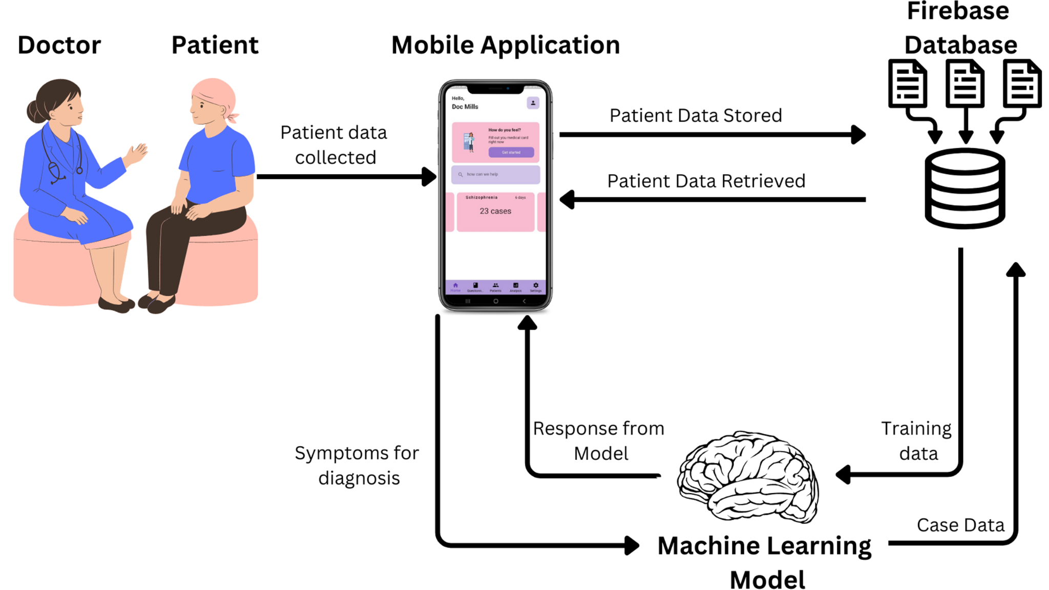

Figure 3.0 System Architecture

**3.1.0** **System overview and functions**

The mental health diagnostic tool is a comprehensive mobile application designed to assist general practitioners in the detection and classification of various mental health disorders strictly used with internet access. The system covers a wide range of conditions, including but not limited to Depression, Schizophrenia, Bipolar Disorder (Types 1 and 2), Generalized Anxiety Disorder, Panic Disorder, Specific Phobia, Social Anxiety Disorder, Obsessive-Compulsive Disorder (OCD), Post-Traumatic Stress Disorder (PTSD), Gambling Disorder, and Substance Abuse Disorder.

The application serves as a decision support system for healthcare providers, guiding them through a structured assessment process that is based on established diagnostic criteria for each disorder. After logging in securely using their email and password which is confirmed by a database server with authorised persons only, General Practitioners are presented with a set of questions tailored to the specific diagnostic criteria of each disorder. These questions cover symptoms and behaviours that align with the clinical guidelines for diagnosis complying to GDPR and HIPAA standards for data protection

### 

### **3.1.1 System Operation**

The operation of the diagnostic tool is structured to be intuitive and efficient for healthcare providers. After logging in with email credentials and verifying their account, the provider is presented with a dashboard displaying the range of mental health disorders that the system supports. From this dashboard, the General practitioner selects the disorder or disorders they wish to assess.

Upon selection, the system generates a series of questions that are aligned with the diagnostic criteria of the chosen disorder. For example, if assessing for Generalized Anxiety Disorder, the system will ask about excessive worry, restlessness, concentration difficulties, and other key symptoms that define the disorder. Similarly, for disorders like bipolar disorder or Schizophrenia, questions will focus on specific mood disturbances or psychotic symptoms.

Each question corresponds to a specific symptom, and the healthcare provider asks the patient these questions during the consultation. Based on the patient’s response, the doctor selects "yes" or "no" to indicate whether the symptom is present. The system dynamically evaluates these responses in real time, calculating a preliminary diagnosis based on the symptoms identified.

The diagnostic process is customised for each disorder, ensuring that key symptoms are weighted appropriately. For example, certain disorders may require a minimum number of specific symptoms to be present, while others may emphasise the importance of key symptoms (such as psychotic features in Bipolar type I which should always be present for Bipolar type I and always be absent for Bipolar type II, or excessive worry in Generalized Anxiety Disorder). The system ensures that these criteria are met before generating a diagnostic result.

After all relevant questions have been answered, the system produces a diagnostic outcome. This result includes a severity score based on how many symptoms are present relative to the total possible symptoms for the disorder which could be mild, moderate, or severe for all the disorders except Bipolar disorder which has the two types expressing the severity in type I and the mild in type II. If a diagnosis is made, additional insights are provided, including which symptoms were most significant, and a visual pie chart representing the severity of the disorders or disorder present.

The General Practitioner can then use this information as part of their broader clinical decision-making process. The tool enables fast, evidence-based diagnoses, improving efficiency, and ensuring that patients receive appropriate care promptly. By automating much of the evaluation process, the system minimises human error and standardises the diagnostic approach across different practitioners.

**3.2 Requirements analysis and specifications**   
  
**3.2.1 Functional Requirements**

Functional requirements define the specific behaviour or functions of the system that are essential to meet the project objectives. For a multi-label classification of mental health disorders, these could include:

* **Data Collection**: The system must collect user data through the mobile app, such as responses to mental health assessments.
* **Preprocessing**: The system must preprocess raw data, handling missing values as a No response to ensure that it is suitable for input into the machine learning model.
* **Multi-Label Classification**: The machine learning model must detect and classify multiple mental health disorders based on the input features from the mobile app.
* **Model Training and Evaluation**: The system should include a machine learning pipeline that allows the training of the multi-label classification model using labelled training data. It must also evaluate the model's performance using appropriate metrics such as precision, recall, F1-score, and accuracy across multiple labels(MHDs).
* **Diagnosis Generation**: Based on the model's predictions, the system should generate a diagnosis report for the patient, listing potential mental health disorders and their severities.
* **Treatment Recommendations**: The system should provide treatment or intervention recommendations based on the predicted disorders, utilising predefined guidelines and clinical resources.
* **Data Security and Privacy**: Ensure secure transmission and storage of sensitive patient data in compliance with privacy regulations (e.g., GDPR, HIPAA).

#### 

#### 

#### 

#### 

#### **3.2.2 Non-Functional Requirements**

Non-functional requirements define the system’s quality attributes and operational constraints:

* **Performance**: The system must be able to process and predict mental health conditions within a reasonable timeframe, ensuring timely diagnosis for users.
* **Scalability**: The system should be scalable to handle a large number of users and their data as the app grows.
* **Accuracy and Reliability**: The classification model must achieve a high level of accuracy and reliability in its predictions to provide meaningful insights into mental health conditions.
* **Usability**: The mobile app interface should be intuitive and user-friendly to encourage regular use by medical professionals.
* **Security**: All user data must be encrypted, both at rest and in transit, ensuring compliance with medical data protection standards.
* **Maintainability**: The system should be designed in a modular manner, allowing easy updates to the machine learning model and mobile app.

#### 

#### **3.2.3 System Specifications**

The system specifications outline the technical environment and resources necessary to develop and deploy the project:

* **Hardware Requirements**:
  + Servers with sufficient processing power and memory to train and run the machine learning models.
  + Secure storage solutions for patient data, such as cloud-based databases with encryption.
* **Software Requirements**:
  + **Mobile Application Development**: Developed using Flutter.
  + **Backend Services**: Cloud-based platforms such as Firebase for real-time data handling and secure storage.
  + **Machine Learning Frameworks**: Scikit-learn for building and training the multi-label classification models.
  + **Database**: A NoSQL database (Firebase Firestore) to store user data securely.
  + **Programming Languages**: Python for the machine learning model development and Dart for the mobile application.
* **Network Requirements**:
  + Reliable and secure internet connectivity to transmit data between the app and the server for real-time processing.

**3.3 Theoretical framework and assumptions**

In developing the theoretical framework for our system, we made the assumption that input data would be binary, consisting solely of "yes" or "no" responses. This simplification was necessary to streamline the diagnostic process and align with the system's capabilities. We deliberately chose not to include nuanced or detailed answers, as processing such data would fall within the domain of natural language processing (NLP), which was beyond the scope of our project. This binary approach allowed us to focus on efficiently detecting and classifying mental health disorders while maintaining clarity and accuracy in the input data.

**3.4 Model Development**

**3.4.1** **Machine Learning Model Development**

For this project, a machine learning classification model was developed to detect various mental health disorders based on the presence of symptoms. The model utilised 101 input features, each representing a symptom associated with the 15 mental health disorders considered in this study. These disorders include Depression, Anxiety, Bipolar Disorder, Schizophrenia, Substance Abuse, and others.

To handle the complexity of comorbidities, where multiple disorders may be present simultaneously, a multi-class classification approach was adopted. The initial model iterations focused on detecting single disorders and as the model was refined, its capacity to recognize co-occurring disorders(comorbidities) improved significantly.

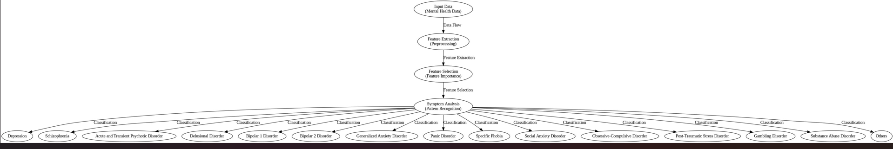

Figure 3.10 - Mental Health Disorder Breakdown

The output layer of the model consists of 15 classes, representing the different mental health conditions being evaluated. Through feature relevance techniques, the most important features (symptoms) contributing to the predictions were identified, further refining the model's accuracy. This approach enabled the system to accurately classify patients into their respective disorder categories or combinations of disorders when comorbidities were detected.

Ultimately, this design allowed the model to deliver high accuracy in predicting both individual disorders and comorbidities, ensuring a robust solution for mental health diagnosis.

**3.4.2 Feature Identification and Selection**

The table below shows the features extracted from the DSM-5 and ICD-11[15] being used for diagnosis. A total of 101 features were gathered to be used for the classification by the model with some of the features in the same or similar spectrum overlapping and some repeating themselves.

|  |  |  |  |  |  |
| --- | --- | --- | --- | --- | --- |
| **Feature code** | **Feature Name** | **Feature code** | **Feature Name** | **Feature code** | **Feature Name** |
| F1 | Depressive mood | F2 | Loss of pleasure | F3 | Cognitive symptoms |
| F4 | Behavioural symptoms | F5 | Changes in sleep patterns | F6 | Feeling worthless |
| F7 | Suicidal thoughts | F8 | Low energy and Fatigue | F9 | Irritability |
| F10 | Disturbed sleep | F11 | Indecisiveness | F12 | Talking or moving slow |
| F13 | Reduced libido | F14 | Delusions | F15 | Hallucinations |
| F16 | Disorganised thinking | F17 | Disturbance in multiple mental modalities | F18 | Functional decline |
| F19 | Negative symptoms | F20 | Family history | F21 | Neurological soft signs |
| F22 | Not influenced by drugs | F23 | Hallucinations emerge suddenly peaking for two weeks | F24 | Delusion emerges suddenly and peak for two weeks |
| F25 | Disorganised speech | F26 | Delirium | F27 | Catatonia-like symptoms |
| F28 | No need for hospitalisation | F29 | Delusions lasting for six months | F30 | Absence of schizophrenia-like symptoms |
| F31 | Absence of mood episodes | F32 | Persistence of delusions | F33 | Presence of one or more delusions within a month |
| F34 | Presence of perceptual disturbance | F35 | Less impairment in function | F36 | Flying thoughts |
| F37 | Engagement in Risky activities | F38 | Mood disturbances | F39 | Prolonged or heightened mood |
| F40 | Severe mood disruption needing hospitalisation | F41 | Risky behaviours persist over a week | F42 | Not attributed to substance use |
| F43 | Presence of psychotic symptoms | F44 | Clear change in functioning in the individual | F45 | Change in functioning is observable by others |
| F46 | Depressive episodes | F47 | Excessive worry | F48 | Worry involves three conditions |
| F49 | Persistent anxiety over various aspects lasting six months | F50 | Difficulty controlling the worry | F51 | Anxiety causes distress |
| F52 | Not attributed to substance use or physiological conditions | F53 | Not confined to specific situations | F54 | Recurrent panic attacks |
| F55 | Discrete episodes of intense fears | F56 | The fear or attacks is spontaneous | F57 | Worries about future episodes |
| F58 | Marked obsessive fears triggered by situations | F59 | Object promotes immediate fear | F60 | Active avoidance |
| F61 | Fear causes clinical distress | F62 | Fear is out of proportion | F63 | Fear last for a really long time |
| F64 | Intense anxiety always present | F65 | Marked avoidance of object | F66 | Fear is out of proportion |
| F67 | Fear causes impairment in function | F68 | Situation provokes fear | F69 | Fear of being judged in social events or situations |
| F70 | Fear of negative evaluation | F71 | Symptoms lead to physical reactions | F72 | Persistent fear in social situations |
| F73 | Emotional distress | F74 | Recognize avoidance are excessive | F75 | Symptoms restricted to the situation |
| F76 | Obsessive and or compulsive thoughts | F77 | Not influenced by drugs | F78 | Uncontrollable obsessive thoughts |
| F79 | Duration of three weeks | F80 | Traumatic experience | F81 | Avoiding the stressor |
| F82 | Cognitive and emotional changes | F83 | Arousal changes | F84 | Flashback |
| F85 | Causes significant impairment in social activities | F86 | Causes significant impairment in functioning | F87 | Do you gamble |
| F88 | Persistent or recurrent gambling | F89 | Prioritisation | F90 | Impaired control |
| F91 | Continuation despite harm | F92 | Use of alcohol or illicit drugs | F93 | Use of unprescribed drugs |
| F94 | Increase in dosage | F95 | Uncontrollable desire | F96 | Neglect of social activity |
| F97 | Use despite harm | F98 | Withdrawal symptom | F99 | 12 months duration |
| F100 | Age | F101 | Gender |  |  |

Table 3.0 - Total Number of Input Features

**3.4.3 Feature Relevance**

The figure below demonstrates the relative importance of different features in the classification of mental health disorders. Each feature contributes to the model's accuracy by varying degrees, with certain features showing significantly higher relevance. For instance, features like **F47 and F76** have been identified as critical in distinguishing between specific mental health conditions, whereas others, such as **F52**, play a lesser but still notable role.

This distribution of feature relevance suggests that the model relies heavily on key symptoms for accurate classification. High-relevance features, such as **F47**, may correspond to diagnostic criteria that are strongly indicative of certain disorders. On the other hand, lower-relevance features might still contribute but are less determinative in isolation.

Understanding the relative importance of these features not only helps in improving the model’s interpretability but also provides insights into which symptoms or factors are most critical for clinicians to consider when diagnosing mental health disorders.

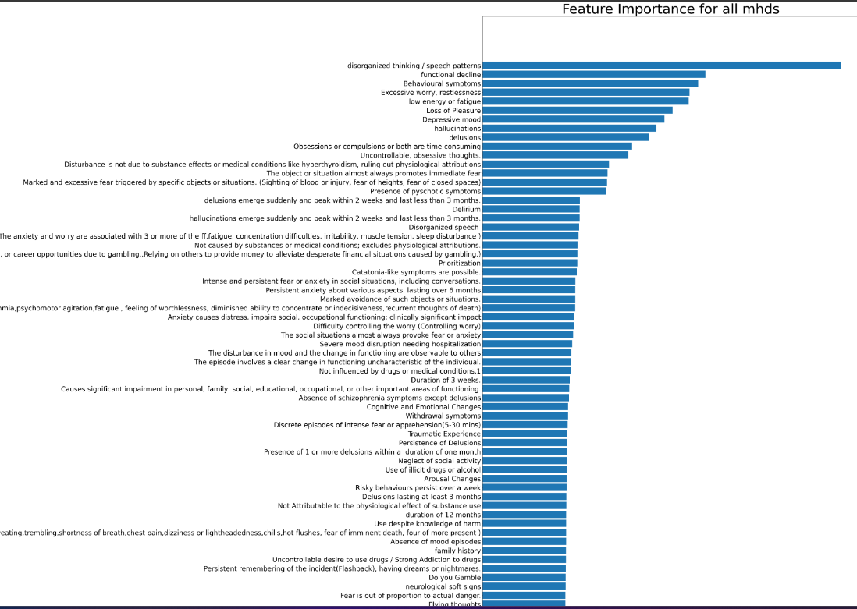

Figure 3.11 - Feature relevance for all MHDs

The figure above shows the feature relevance for all the MHD’s the model considers

**3.4.4 Data Processing**

To process the data for each mental health disorder, a binary classification system was applied: “yes” indicated the presence of a feature, while “no” represented its absence. The "yes" responses were assigned a binary value of “1,” and "no" responses were assigned a “0.” Before merging the data into a single dataset, separate datasets were created for each disorder. The following tables display code snippets for each disorder and the diagnostic criteria used to generate the data.

**Depression**

Table 3.1 outlines the features identified for Depression. A total of fourteen (14) features were considered, and 10,000 data samples were generated for analysis. To detect Depression, at least **two key features** (such as depressed mood or loss of interest) need to be present, along with **two additional features**. These symptoms should persist for a minimum of two weeks to qualify for a diagnosis.

|  |  |  |  |  |  |
| --- | --- | --- | --- | --- | --- |
| **Feature code** | **Feature Name** | **Feature code** | **Feature Name** | **Feature code** | **Feature Name** |
| D1 | **Depressive mood (key)** | D2 | **Loss of Pleasure(key)** | D3 | Cognitive Symptoms |
| D4 | Behavioural Symptoms | D5 | Changes in Sleep Patterns or Appetite | D6 | Feeling Worthless and Low Self Esteem |
| D7 | Suicidal Thoughts | D8 | **Low Energy or Fatigue(key)** | D9 | Irritability |
| D10 | Disturbed sleep or sleeping too much | D11 | Indecisiveness | D12 | Talking or moving more slowly than usual |
| D13 | Reduced Libido |  |  |  |  |

Table 3.1 - Depression Features

#### **Schizophrenia**

Table 3.2 highlights the features identified for Schizophrenia. A total of nine (9) features were identified, with 10,000 data samples generated. For a diagnosis of Schizophrenia, at least **two key features** (such as delusions or hallucinations) must be present, along with **one other feature**. Symptoms must last for at least six months.

| **Feature code** | **Feature Name** | **Feature code** | **Feature Name** | **Feature code** | **Feature Name** |
| --- | --- | --- | --- | --- | --- |
| S1 | **Delusions(key)** | S2 | **Hallucinations(key)** | S3 | **Disorganised thinking or speech patterns(key)** |
| S4 | Disturbance in multiple mental modalities | S5 | Functional Decline | S6 | Negative Symptoms (Avolition, Agolia, Diminished emotional expression, Anhedonia) |
| S7 | Family History | S8 | Neurological Soft Signs | S9 | Not influenced by drugs or medical conditions |

Table 3.2 - Schizophrenia Features

#### **Acute and Transient Psychotic Disorder**

Table 3.3 outlines the features identified for Acute and Transient Psychotic Disorder. Six (6) features were identified, and 10,000 data samples were generated. Diagnosis requires the presence of **two key features** (such as sudden onset of hallucinations or delusions), along with **two additional features**. The symptoms should last for less than three months.

|  |  |  |  |  |  |
| --- | --- | --- | --- | --- | --- |
| **Feature code** | **Feature Name** | **Feature code** | **Feature Name** | **Feature code** | **Feature Name** |
| A1 | **Sudden Hallucinations peaking within 2 weeks (key)** | A2 | **Delusions emerge suddenly and peak within 2 (key)** | A3 | **Disorganised Speech (key)** |
| A4 | Delirium | A5 | Catatonia-like symptoms are possible | A6 | The disorder does not require hospitalisation |

Table 3.3 - Acute and Transient Psychotic Disorder Features

#### 

#### **Delusional Disorder**

Table 3.4 presents the features identified for Delusional Disorder. Seven (7) features were identified, and 10,000 data samples were generated. To diagnose Delusional Disorder, **two key features** (such as persistent delusions) must be present, along with **one other symptom**. Symptoms must persist for at least one month.

|  |  |  |  |  |  |
| --- | --- | --- | --- | --- | --- |
| **Feature code** | **Feature Name** | **Feature code** | **Feature Name** | **Feature code** | **Feature Name** |
| DD1 | **Delusions lasting at least 3 months (key)** | DD2 | **Absence of Schizophrenia symptoms except Delusions (key)** | DD3 | **Absence of mood episodes (key)** |
| DD4 | Persistence of Delusions | DD5 | Presence of one or more delusions within a duration of one month | DD6 | Presence of perceptual disturbances |
| DD7 | Less impairment in function |  |  |  |  |

Table 3.4 - Delusional Disorder Features

**BIPOLAR DISORDER**

Table 3.5 outlines the features identified for Bipolar Disorder Type 1 and Type II. Eight (8) features were identified for type I and seven for type II, and 10,000 data samples were generated. To detect Bipolar Disorder Type 1, at least **two key features** (such as mood disturbance or irritability) need to be present, along with **one other feature**. Symptoms must persist for at least one week. For Bipolar Disorder Type 2, Seven (7) features were identified, and 10,000 data samples were generated. Diagnosis requires the presence of **two key features** (such as no psychotic symptoms and depressive episodes), along with **two additional symptoms**. These symptoms must persist for at least two weeks. With both type I and type II share the same features like mood disturbance and not attributable to physiological effect of substance use.

|  |  |  |  |  |  |
| --- | --- | --- | --- | --- | --- |
| **Feature code** | **Feature Name** | **Feature code** | **Feature Name** | **Feature code** | **Feature Name** |
| B1 | Flying thoughts | B2 | Excessive involvement in risky activities | B3 | **Mood disturbances (key)** |
| B4 | Prolonged, heightened mood | B5 | **Severe mood disruption needing hospitalisation (key)** | B6 | Risky Behaviours persist over a week |
| B7 | Not attributable to the physiological effect of substance use | B8 | **Presence of psychotic symptoms (key)** | B9 | The episode involves a clear change in functioning characteristics of the individual |
| B10 | The disturbance in mood and the change in functioning are observable to others | B11 | **Depressive Episode (key)** |  |  |

Table 3.5 - Bipolar Disorder Features

#### **Anxiety Disorders**

#### Anxiety disorders encompass a range of mental health conditions characterised by excessive fear, worry, or avoidance of specific situations. Table 3.6 outlines the features identified for the four anxiety-related disorders considered in this project: **Generalized Anxiety Disorder (GAD)**, **Panic Disorder**, **Specific Phobia**, and **Social Anxiety Disorder**. A total of 10,000 data samples were generated to evaluate each disorder. For **GAD**, at least **two key features**, such as **excessive worry** or **persistent anxiety lasting over six months**, are required, along with **two additional features** like fatigue or muscle tension. In **Panic Disorder**, diagnosis relies on the presence of **recurrent panic attacks** or **intense episodes of fear**, along with another symptom, persisting for at least one month. **Specific Phobia** is diagnosed when there is **excessive and immediate fear** triggered by specific objects or situations, along with avoidance behaviours and symptoms persisting for six months or more. Finally, **Social Anxiety Disorder** involves intense fear or anxiety in social situations, with **avoidance of social interactions** and a disproportionate fear of negative evaluation, persisting for at least six months.

|  |  |  |  |  |  |
| --- | --- | --- | --- | --- | --- |
| **Feature code** | **Feature Name** | **Feature code** | **Feature Name** | **Feature code** | **Feature Name** |
| A1 | **Excessive worry (key)** | A2 | **Worry involves three conditions (key)** | A3 | **Persistent anxiety over various aspects lasting six months (key)** |
| A4 | Difficulty controlling the worry | A5 | Anxiety causes distress | A6 | Not attributed to substance use or physiological conditions |
| A7 | **Not confined to specific situations (key)** | A8 | **Recurrent panic attacks (key)** | A9 | Discrete episodes of intense fears |
| A10 | Worries about future episodes | A11 | **Marked obsessive fears triggered by situations (key)** | A12 | Object promotes immediate fear |
| A13 | Active avoidance | A14 | Fear causes clinical distress | A15 | Fear is out of proportion |
| A16 | Intense anxiety always present | A17 | **Marked avoidance of object (key)** | A18 | Fear of event or situation is out of proportion |
| A19 | Fear causes impairment in function | A20 | Situation provokes fear | A21 | Fear of negative evaluation |
| A22 | **Persistent fear in social situations (key)** | A23 | Emotional distress | A24 | Recognize avoidance are excessive |
| A25 | Symptoms restricted to the situation | A26 | Fear takes a long time | A27 | The fear or attacks is spontaneous |
| A28 | Symptoms lead to physical reactions | A29 | Fear of being judged in social events or situations |  |  |

Table 3.6 - Anxiety Features

#### **Obsessive-Compulsive Disorder (OCD)**

Table 3.7 highlights the features identified for obsessive-compulsive disorder (OCD). Four (4) features were identified, and 10,000 data samples were generated. To diagnose OCD, **two key features** must be present, such as repetitive obsessive thoughts or compulsive behaviours, along with **one additional feature**. These symptoms must persist for at least one month.

|  |  |  |  |  |  |
| --- | --- | --- | --- | --- | --- |
| **Feature code** | **Feature Name** | **Feature code** | **Feature Name** | **Feature code** | **Feature Name** |
| O1 | **Obsessions or compulsions (key)** | O2 | Not influenced by drugs or medical conditions(s) | O3 | **Uncontrollable, obsessive thoughts (key)** |
| O4 | Duration of 3 weeks |  |  |  |  |

Table 3.7 - OCD Features

#### **Post-Traumatic Stress Disorder (PTSD)**

Table 3.8 presents the features identified for PTSD. A total of seven (7) features were identified, with 10,000 data samples generated for analysis. For PTSD, **two key features** (such as flashbacks or intrusive thoughts) should be present, along with **one other feature**. Symptoms must persist for more than one month to confirm a diagnosis.

|  |  |  |  |  |  |
| --- | --- | --- | --- | --- | --- |
| **Feature code** | **Feature Name** | **Feature code** | **Feature Name** | **Feature code** | **Feature Name** |
| P1 | **Traumatic experience (key)** | P2 | **Avoiding the stressor (key)** | P3 | Cognitive and emotional changes |
| P4 | Arousal Changes | P5 | **Flashbacks (key)** | P6 | Causes significant impairment in personal, family, social, educational, occupational or other important areas of functioning |
| P7 | It causes impairment in functioning |  |  |  |  |

Table 3.8 - PTSD Features

#### **Gambling Disorder**

Table 3.9 highlights the features identified for Gambling Disorder. Five (5) features were identified, and 10,000 data samples were generated. A diagnosis of Gambling Disorder requires the presence of **two key features** (such as persistent problematic gambling behaviour or impaired control), along with **one additional feature**. Symptoms should persist for at least one year.

|  |  |  |  |  |  |
| --- | --- | --- | --- | --- | --- |
| **Feature code** | **Feature Name** | **Feature code** | **Feature Name** | **Feature code** | **Feature Name** |
| G1 | Gambling behaviour | G2 | **Recurring problematic gambling behaviour (key)** | G3 | **Prioritisation (key)** |
| G4 | **Impaired Control (key)** | G5 | Continuation despite harm |  |  |

Table 3.9 - Gambling Features

**Substance Use and Abuse Disorder** Table 3.10 outlines the features identified for Substance Use and Abuse Disorder. Eight (8) features were identified, and 10,000 data samples were generated. To diagnose Substance Use and Abuse Disorder, the presence of **two key features** (such as impaired control and continued use despite harm) is required, along with **two additional features**. These symptoms must persist for at least one year.

|  |  |  |  |  |  |
| --- | --- | --- | --- | --- | --- |
| **Feature code** | **Feature Name** | **Feature code** | **Feature Name** | **Feature code** | **Feature Name** |
| SA1 | **Use of illicit drugs or alcohol (key)** | SA2 | **Use of unprescribed medication (key)** | SA3 | **Increase in Dosage (key)** |
| SA4 | Uncontrollable Desire to use drugs | SA5 | Neglect of social activity | SA6 | Use despite knowledge of harm |
| SA7 | Withdrawal symptoms | SA8 | Duration of 12 months |  |  |

Table 3.10 - Substance Use And Abuse Features

**3.4.5 Data distribution**

Figure 3.21 - Gender and Age Distribution for all MHDS taken over 10,000 samples

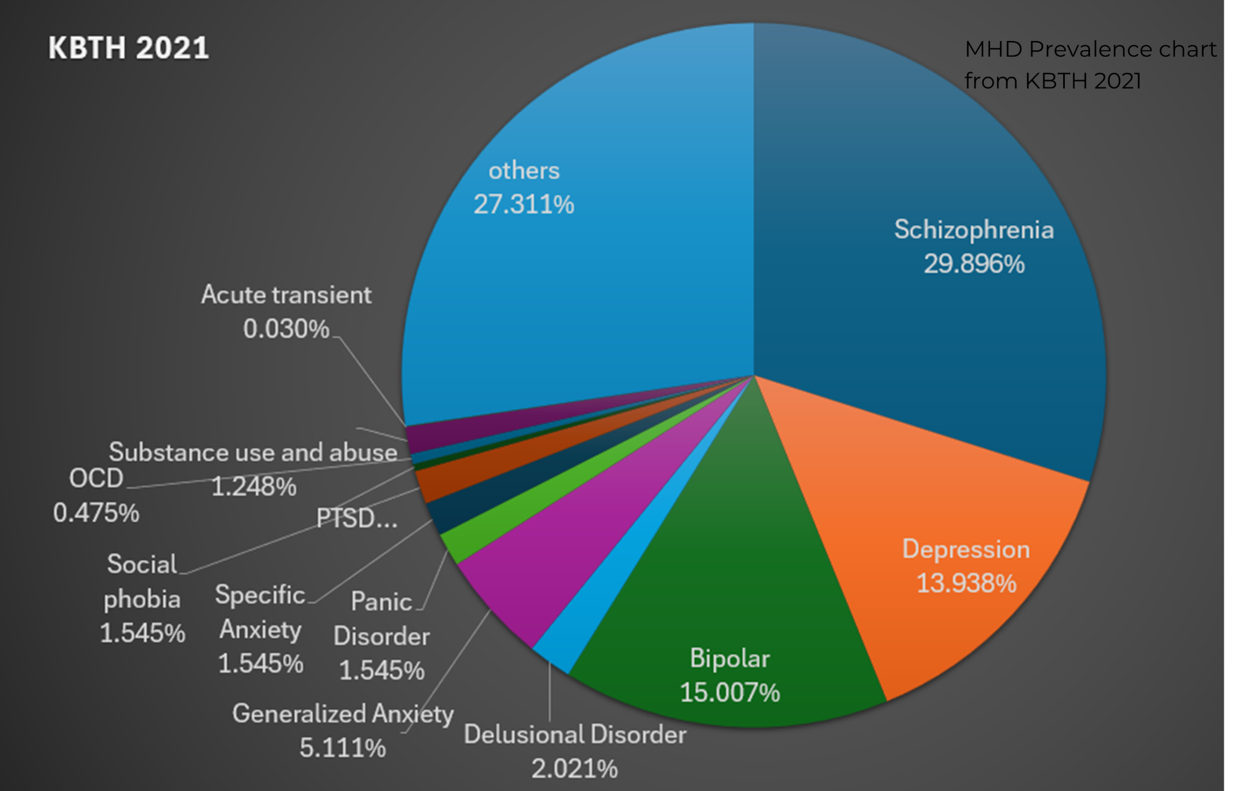

Figure 3.20 - Distribution of the mental health disorders prevalence as of 2021

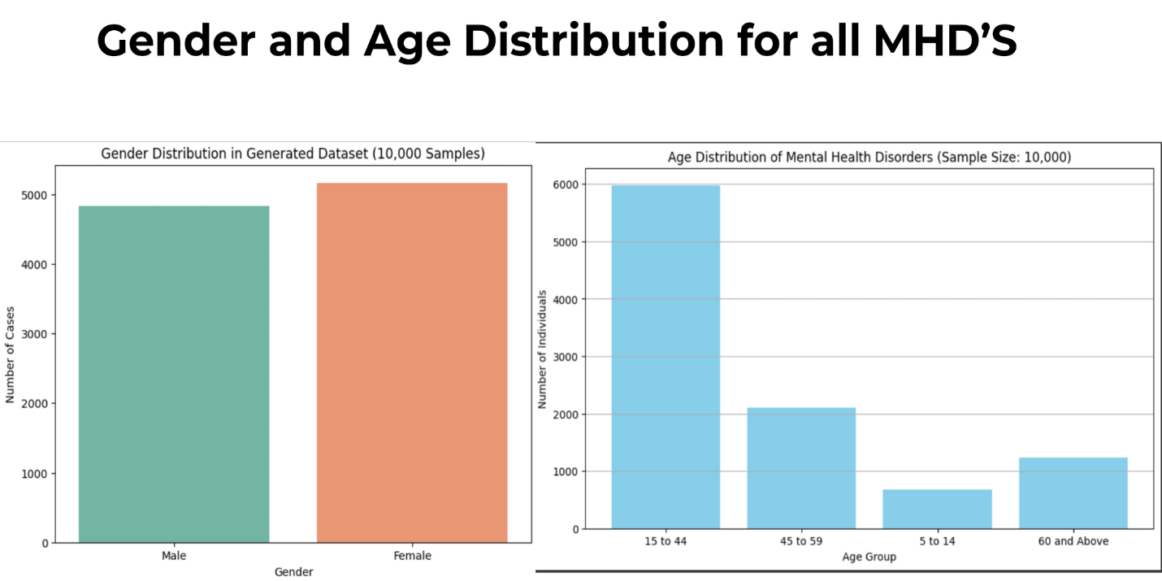

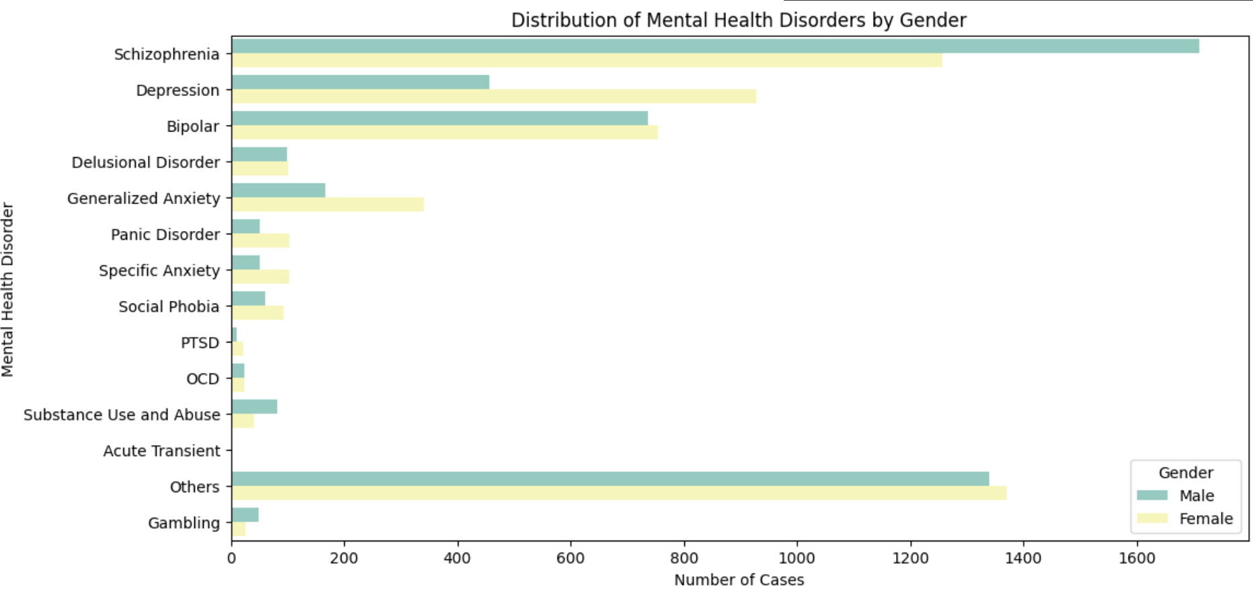

Figure 3.22 - Gender Distribution for all MHDS

**3.5 Model Selection**

Upon evaluating various models based on accuracy and execution time, the Gradient Boosting Machine (GBM) emerged as the preferred choice due to its strong performance. The GBM model achieved a notable accuracy of 97% and demonstrated a prediction time of 0.372680. This model showed the best results among the alternatives, striking a balance between high classification accuracy and reasonable prediction time.

|  |  |  |  |  |
| --- | --- | --- | --- | --- |
| MODELS USED | PRECISION | RECALL | F1 SCORE | Training Accuracy |
| K-Nearest Neighbours | 0.54 | 0.42 | 0.46 | 0.023 |
| Random Forest Classifier | 0.53 | 0.38 | 0.37 | 0.085 |
| SVM | 0.87 | 0.83 | 0.84 | 0.3605 |
| Adaboost Classifier | 0.83 | 0.79 | 0.81 | 0.823 |
| Multi-Layer Perceptron | 0.95 | 0.95 | 0.95 | 0.91 |
| Gradient boosting Machines | 0.98 | 0.98 | 0.98 | 0.971 |

Table 3.11 - Models Used and their Training metrics

|  |  |  |  |  |
| --- | --- | --- | --- | --- |
| MODELS USED | PRECISION | RECALL | F1 SCORE | Testing Accuracy |
| K-Nearest Neighbours | 0.52 | 0.48 | 0.47 | 0.028 |
| Random Forest Classifier | 0.51 | 0.31 | 0.37 | 0.089 |
| SVM | 0.88 | 0.87 | 0.85 | 0.3812 |
| Adaboost Classifier | 0.84 | 0.78 | 0.80 | 0.841 |
| Multi-Layer Perceptron | 0.92 | 0.93 | 0.96 | 0.92 |
| Gradient boosting Machines | 0.97 | 0.98 | 0.98 | 0.975 |

Table 3.12 - Models Used and their Testing metrics

The performance metrics of the selected GBM model are summarised in the Table below. The table highlights the model's performance metrics, emphasising its effectiveness in classifying mental health disorders. The GBM model's high accuracy underscores its reliability and suitability for the classification task in our project.

|  |  |  |  |
| --- | --- | --- | --- |
| **Disorders** | **Precision** | **Recall** | **F1-score** |
| Depression | 0.94 | 0.99 | 0.96 |
| Schizophrenia | 0.99 | 0.99 | 0.99 |
| Acute and transient | 0.99 | 0.97 | 0.98 |
| Delusional Disorder | 1.00 | 0.98 | 0.99 |
| Bipolar Type I | 0.99 | 0.97 | 0.98 |
| Bipolar Type II | 0.99 | 0.98 | 0.98 |
| Generalized Anxiety | 0.99 | 0.97 | 0.98 |
| Panic Disorder | 0.97 | 0.99 | 0.98 |
| Specific Phobia | 0.99 | 0.98 | 0.99 |
| Social Anxiety | 0.94 | 0.99 | 0.96 |
| OCD | 1.00 | 0.97 | 0.98 |
| PTSD | 0.99 | 0.99 | 0.99 |
| Gambling Disorder | 1.00 | 0.97 | 0.98 |
| Substance Use and Abuse | 0.98 | 0.97 | 0.98 |
| OTHERS | 0.99 | 0.99 | 0.99 |

Table 3.13 - GBM model performance metrics against Mental Health Disorders

**3.6 Model Training and Testing**

For the development of our mental health classification system, we employed a range of machine learning models to address the challenge of accurately identifying and classifying mental health disorders from the dataset. To ensure effective learning and evaluation, 70% of the dataset, which amounted to 7,000 instances, was used for training the models, while the remaining 30% was reserved for testing.

Our approach began with the creation of a Multi-Layer Perceptron (MLP) model featuring two hidden layers. Each hidden layer utilised the Rectified Linear Unit (ReLU) activation function, a choice that helps in capturing complex relationships and improving the overall performance of the model. For the output layer, we implemented the SoftMax activation function to handle the multi-class classification task, where each disorder is treated as a distinct class. This setup allowed the model to predict the probability distribution across multiple classes effectively.

To optimise the training process, we used the Adam optimizer, which is known for its efficiency in handling large datasets and complex models. The categorical cross-entropy loss function was employed, suitable for multi-class problems as it evaluates the difference between the predicted probability distribution and the true class labels. The models were trained using 7,000 instances, and hyperparameters were fine-tuned during this phase to enhance model performance.

After training, the models were evaluated using the instances from the test set to assess their classification accuracy. This step was crucial in determining the best-performing model based on its ability to generalise to new, unseen data. This comprehensive approach allowed us to develop robust models capable of accurately identifying and classifying mental health disorders, ensuring that the system performs well across different scenarios.

**3.7 Model Performance Evaluation**

To improve the robustness and generalisation of the machine learning model, Gaussian noise was added to the synthetically generated data because the training accuracy without noise (table below) gave a really high accuracy, so the Gaussian noise was used to make the data more realistic this is because

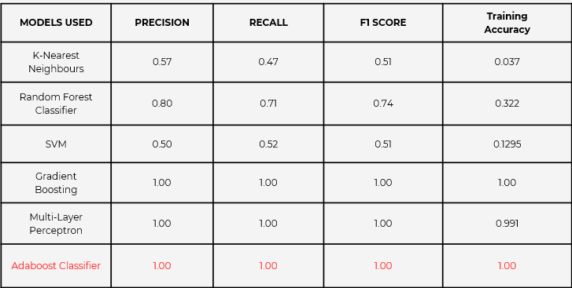

Figure 3.23 - Model Metrics before noise was added to dataset

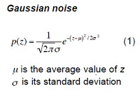

Equation 3.1 - Gaussian Noise Equation [18]

1) Gaussian noise[18] as compared with other noises has mathematical properties, such as a mean of 0 and defined standard deviation, make it easy to control

2) Many real-world phenomena exhibit Gaussian-like noise, providing realistic simulations

3) it aids in regularisation, helping models generalise better by preventing overfitting

Therefore, Gaussian noise with a mean of 0 and a standard deviation of 0.1, was introduced to artificially increase the variance in the dataset. This technique as pointed out helps prevent the model from overfitting to the training data by simulating the small variations that may occur in real-world user data. The noise was added to the input features to make the model more resilient to slight fluctuations in the data, which is particularly useful for ensuring that the multi-label classification of mental health disorders can generalise well to unseen, noisy data. This step is crucial in the context of mental health, where data might not always be perfectly consistent across users or sessions.

|  |  |
| --- | --- |
| **Disorders** | **Number in classification Report** |
| Depression | 0 |
| Schizophrenia | 1 |
| Acute and transient | 2 |
| Delusional Disorder | 3 |
| Bipolar Type I | 4 |
| Bipolar Type II | 5 |
| Generalized Anxiety | 6 |
| Panic Disorder | 7 |
| Specific Phobia | 8 |
| Social Anxiety | 9 |
| OCD | 10 |
| PTSD | 11 |
| Gambling Disorder | 12 |
| Substance Use and Abuse | 13 |
| OTHERS | 14 |

Table 3.14 - Position of Disorders in Classification Report

### **Random Forest**

The Random Forest model reveals its limitations in handling the imbalance or complexity of certain classes. While it performs reasonably well in a few areas, such as class 0 and class 1 (precision nearing 0.90), the performance across other classes is less than optimal. Many of the classes, particularly 2, 3, 5, and 11, show no significant prediction capabilities, evidenced by very low recall and f1-scores. This suggests that while Random Forest is useful for high-support disorders, it struggles with less frequent or more nuanced cases, which may point to a lack of depth in learning patterns from the dataset.

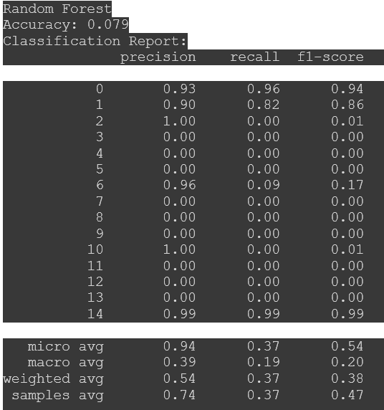

Figure 3.24 - Random Forest model metrics

### **SVM (Support Vector Machine)**

The SVM model performs strongly across most categories, particularly in predicting common disorders with a high precision-recall balance. Disorders like class 0, 1, and 2 demonstrate precision and recall values nearing 0.90 and above, indicating that SVM effectively discriminates between these disorders. However, it struggles with more difficult cases such as class 7, 9, 11, and 13, where precision and recall both drop. Specifically, class 11 (f1-score 0.32) and class 13 (f1-score 0.31) reflect the challenges the model faces in identifying these particular disorders. Nonetheless, the model is notably robust for major and well-represented classes.

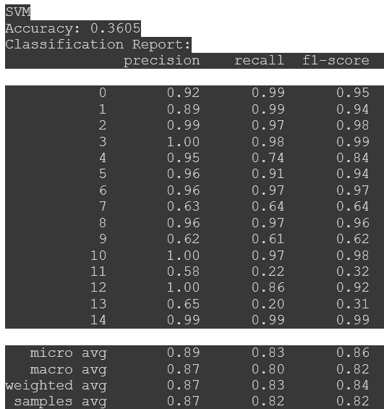 Figure 3.25 - SVM model metrics

**K-Nearest Neighbors (KNN)**

The KNN model, while effective for some classes, tends to be less consistent overall. Precision values hover between 0.34 and 0.69, with recall lagging behind in most classes, such as 7 and 9. Notably, the f1-scores for classes 7, 11, and 13 reveal substantial weaknesses, with values hovering between 0.25 and 0.35. This model shows some promise for well-defined cases, but overall, it exhibits limitations in handling the complexity and overlaps between certain disorders, particularly where a clearer boundary between class features is necessary.

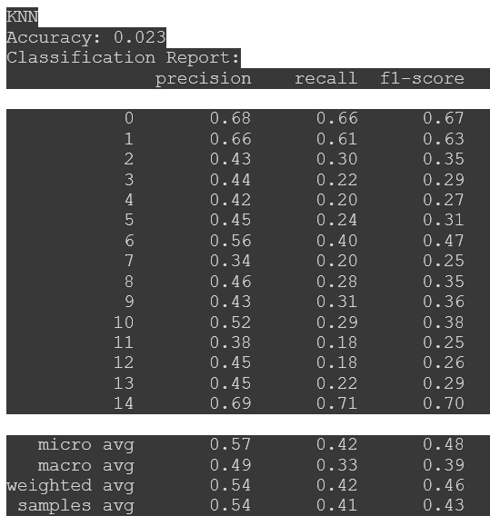

Figure 3.26 - KNN model metrics

**AdaBoost**

AdaBoost emerges as a relatively balanced model, maintaining reasonable performance across most classes. While precision is consistently high in many categories—especially classes like 0, 1, 2, and 12—the recall for certain lower-support classes (such as7, 9 and 11) brings the overall f1-scores down. The model handles well-represented classes effectively, but it displays mixed results with underrepresented ones. Despite this, AdaBoost’s ability to generate good f1-scores (above 0.80) in most areas reflects its potential in handling diverse data.

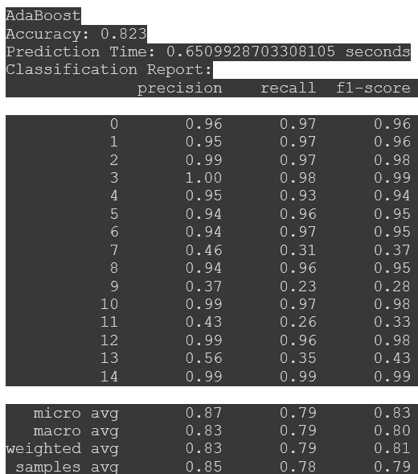

Figure 3.27 - Adaboost model metrics

### **MLP (Multilayer Perceptron)**

MLP demonstrates strong predictive power, excelling in most categories with precision and recall scores often near or above 0.95. The model handles diverse classes with a high degree of consistency, even for challenging categories like class 7 and 9, which show respectable f1-scores. The combination of high precision and recall in a wide range of disorders, including rare cases like class 13, speaks to the model’s strength in learning from data across the board, making it one of the top performers for reliable disorder classification.

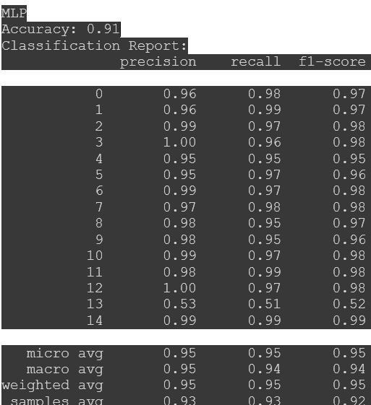

Figure 3.28 - MLP model metrics

### **Gradient Boosting Machine (GBM)**

GBM stands out as one of the most effective techniques, achieving near-perfect precision, recall, and f1-scores in almost all classes. Disorders such as class 0, 1, 4, 9, and 14 are handled particularly well, with most f1-scores above 0.95. Even for more nuanced cases, such as class 7 and 11, the model demonstrates a superior ability to distinguish between features and outcomes. Its ability to balance recall with precision across most classes makes GBM a highly reliable model for this task, likely due to its iterative learning and ability to refine predictions across weak learners.

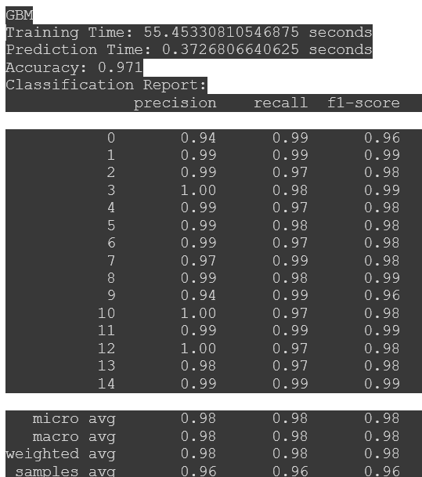

Figure 3.29 - GBM model metrics

**3.8 Application Software Development**

**3.8.1 Server Development**

The server-side architecture of the project is built around the key functionality of classifying mental health disorders based on user inputs. The server handles data processing, model inference, and securely delivers the results to the mobile application in real-time. To achieve this, a robust backend was designed using **FastAPI**, which provides the high performance and low latency necessary for the project’s classification tasks.

#### **1. Backend Infrastructure**

The backend leverages **FastAPI** to expose a /classify endpoint, which interacts with the machine learning model and returns predictions and probabilities for a variety of mental health disorders. **Firebase** was used as the backend for storing patient data, which includes both the raw input data (e.g., user responses or features extracted from the mobile app) and the classification results. Firebase’s real-time database and security features provided a scalable and secure solution for managing sensitive medical data.

#### **2. API Design and Model Inference**

The primary endpoint of the backend, /classify, is responsible for receiving the input data from the mobile application, preprocessing it, running it through the Gradient Boosting Machine (GBM) model, and returning both the predicted disorders and their respective probabilities.

The API returns a structured JSON object with two key components:

* **Prediction**: A dictionary where each key represents a mental health disorder and the value indicates whether the disorder is predicted as present (binary classification).
* **Probabilities**: A dictionary that maps each mental health disorder to the probability score returned by the model, which provides a confidence measure for each prediction.

Example response from the /classify endpoint:

Json Format:

{

"Prediction": {

"Depression": True,

"Schizophrenia": False,

"Acute_and_transient_psychotic_disorder": False,

"Delusional_Disorder": True,

"BiPolar1": False,

"BiPolar2": False,

"Generalized_Anxiety": True,

"Panic_Disorder": False,

"Specific_Phobia": False,

"Social_Anxiety": False,

"OCD": True,

"PTSD": True,

"Gambling": False,

"substance_abuse": False

},

"Probabilities": {

"Depression": 0.85,

"Schizophrenia": 0.12,

"Acute_and_transient_psychotic_disorder": 0.05,

"Delusional_Disorder": 0.76,

"BiPolar1": 0.40,

"BiPolar2": 0.30,

"Generalized_Anxiety": 0.88,

"Panic_Disorder": 0.20,

"Specific_Phobia": 0.15,

"Social_Anxiety": 0.25,

"OCD": 0.82,

"PTSD": 0.78,

"Gambling": 0.10,

"substance_abuse": 0.35

}

}

Figure 3.30 – JSON Object Representation

This structured output allows the mobile application to present both the disorder predictions and the confidence level of each prediction to the user, enabling a nuanced understanding of their mental health status.

#### **3. Model Deployment and Interaction**

The Gradient Boosting Machine (GBM) model is hosted on the cloud and exposed through the /classify API endpoint. FastAPI ensures fast inference times, allowing the system to handle multiple concurrent requests efficiently. Upon receiving a request, the backend performs data validation and preprocessing to ensure that the input format aligns with the model's requirements.

The preprocessed data is then passed to the machine learning model, which performs multi-label classification. The resulting predictions and probabilities are returned in the structured JSON format shown above, which allows for real-time feedback to the user.

#### **4. Security and Data Privacy**

Since the system handles sensitive mental health data, security measures were prioritised during server development. All data transmitted between the mobile app and the server is encrypted using **SSL/TLS** to protect against unauthorised access. Firebase Authentication is employed to verify users before they can access the system, ensuring that patient data is only available to authorised personnel.

Moreover, the classification results and user data stored in the Firebase database are encrypted at rest. The system complies with industry-standard privacy regulations, such as **HIPAA**, ensuring that all patient data is handled securely and confidentially.

#### **5. Scalability and Performance**

The server architecture is designed to be scalable, leveraging Firebase’s serverless capabilities to automatically handle increasing user load. As the system grows, Firebase can efficiently scale its storage and processing power, ensuring that the server remains responsive and that classification results are delivered with minimal latency.

FastAPI’s high-performance capabilities, combined with optimised data pipelines and caching mechanisms, allow the model to perform real-time inferences with low latency. This ensures that users receive prompt and accurate mental health diagnoses, enhancing the overall user experience.

**3.8.2 Mobile App Development with Flutter**

The mobile application was developed using Flutter, with Firebase Authentication implemented for user authentication. The application is capable of performing various functions, including user onboarding, authenticating routes, adding new patients, conducting diagnoses, inputting patient data, and managing user accounts through login and registration features. Figure 3.31 illustrates the various components of the application as well as how users interact with them. 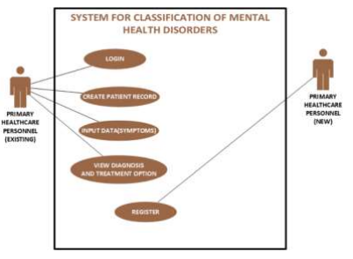Additionally, the application's functionality and data flow are depicted in Figure 3.32.

Figure 3.31 – Use case diagram for mobile application

Figure 3.32 - Operational Flow Chart 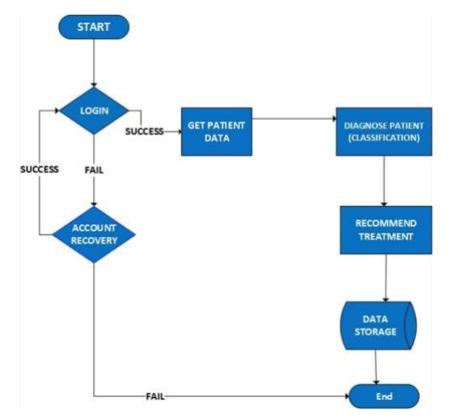

Upon initialising the system, the user is prompted to go through the authentication process, which includes signing in or signing up for new users. An account recovery feature is integrated to assist users in case of authentication issues. Once successfully signed in, the doctor can create a new patient record by entering the patient’s details and proceed to gather information about the patient’s symptoms. The user is then directed to a questionnaire page where they interact with the patient, selecting "yes" or "no" based on the patient’s responses to specific questions. These questions are directly linked to symptoms, which are then fed into the machine learning model in binary format.

The machine learning model performs detection and classification across the fourteen (14) specified Mental Health Disorders (MHDs), as well as an additional "Others" category to flag disorders not explicitly covered by the system. The model then returns the results, including the suspected MHD(s) and recommended actions, which are displayed to the user in a graphical format. A comprehensive report is generated, containing recommendations and referral options based on the model’s predictions. In cases of depression, the SAD PERSONS Scale is used to evaluate severity and suggest appropriate measures. Table 3.15 provides a description of the SADPERSONS Scale.

|  |  |  |  |  |  |
| --- | --- | --- | --- | --- | --- |
| **Letter** | **Description** | **Letter** | **Description** | **Letter** | **Description** |
| S | Sex | A | Age | D | Depression |
| P | Previous attempt | E | Ethanol abuse | R | Rational thinking loss |
| S | Social Support lacking | O | Organised plan | N | No Partner / Divorced |
| S | Sickness |  |  |  |  |

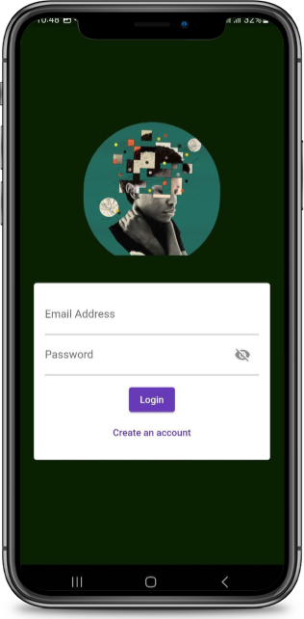Table 3.15 – SADPERSON Scale Description

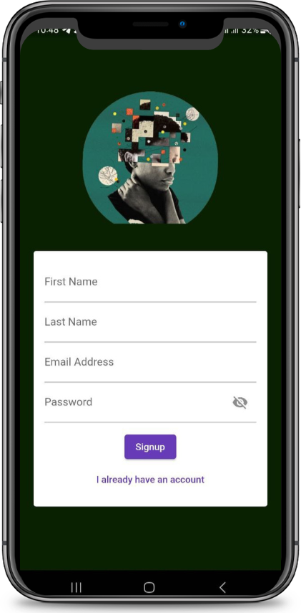

Figure 3.33 – Application registration page Figure 3.34 – Application login page

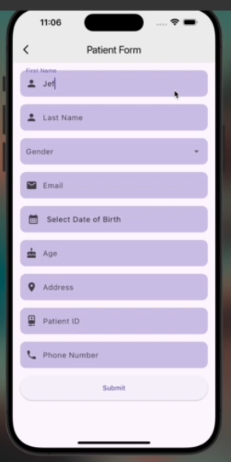

Figure 3.35- Patient personal data form

Figure 3.36 – Interface for physical examination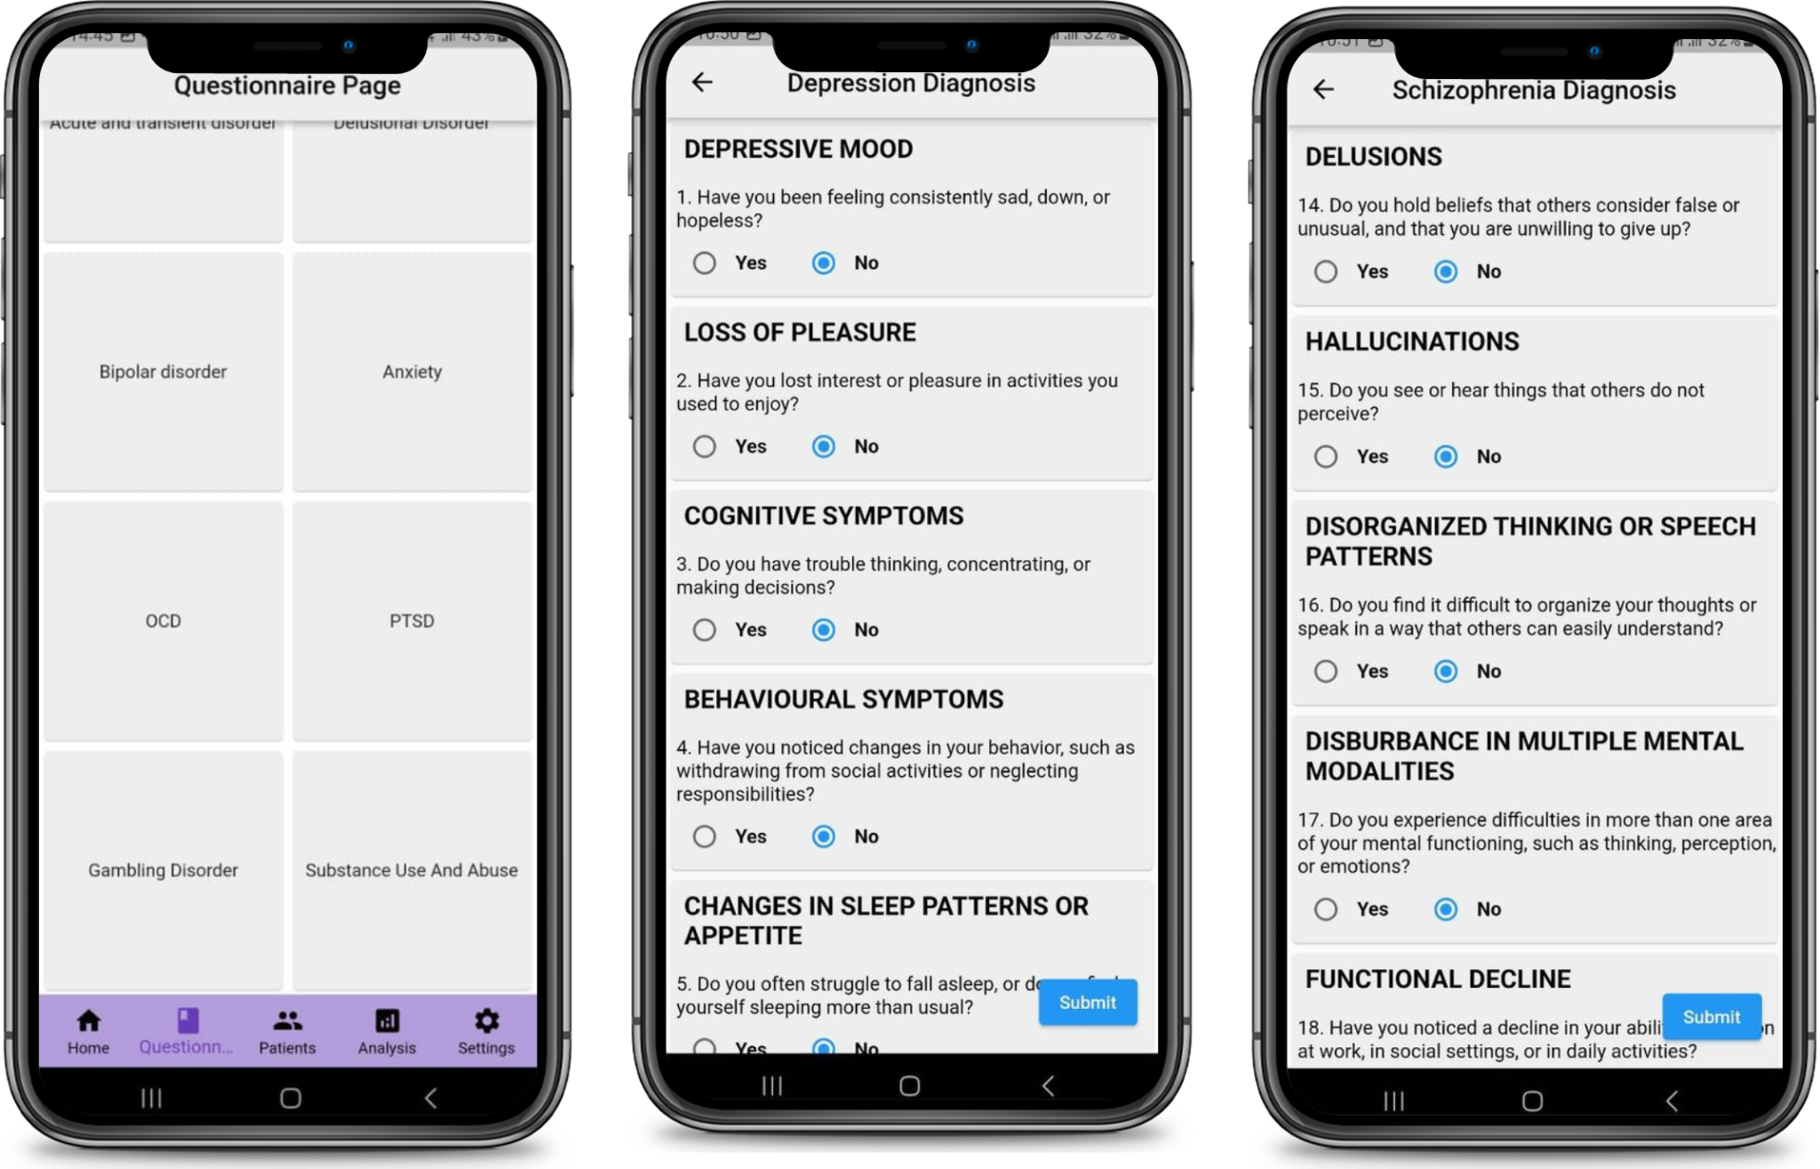

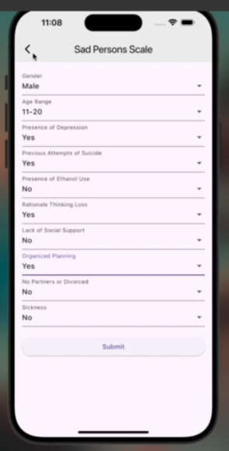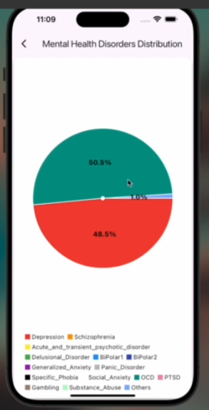

Figure 3.37 – Interface to display classification results from model Figure 3.38 – Interface for SADPERSONS scale

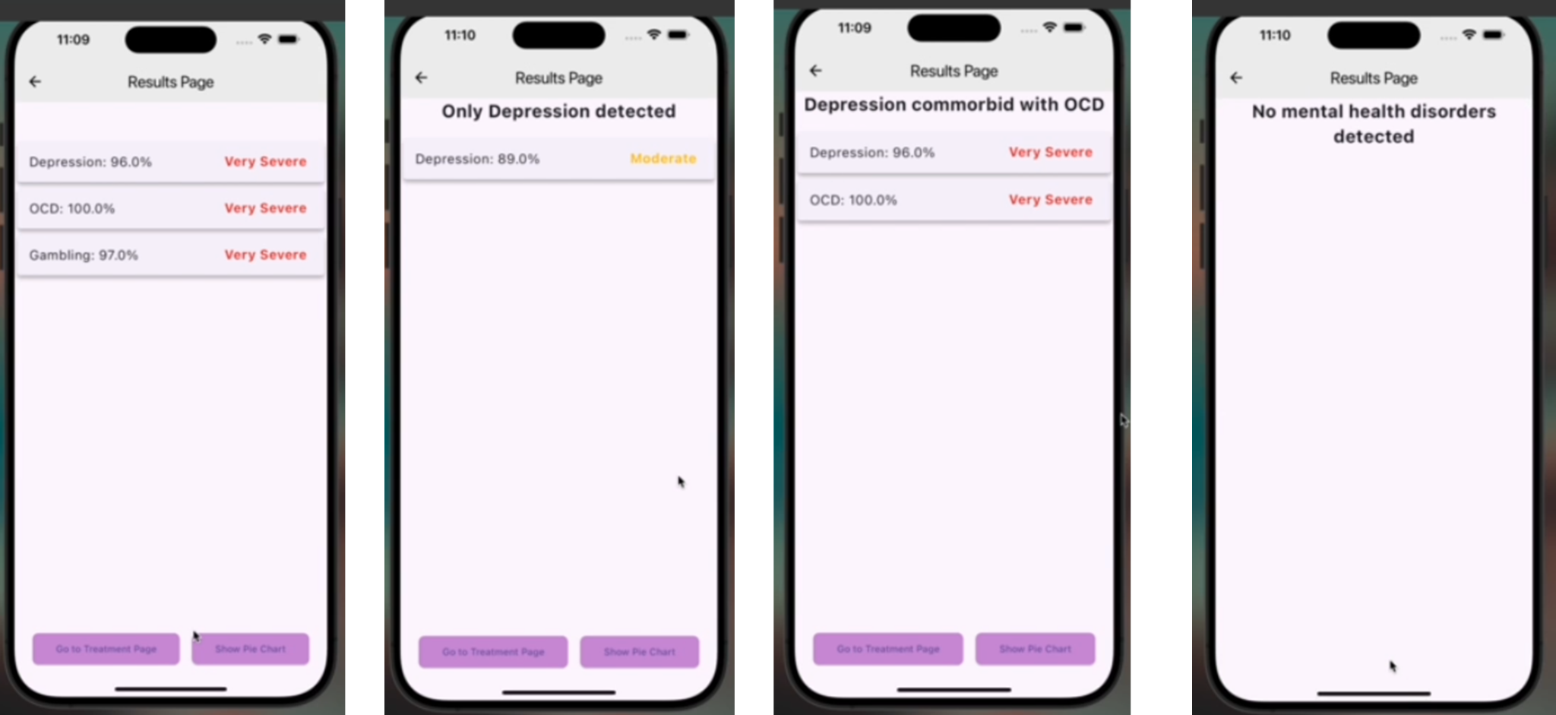

Figure 3.39 – Final report showing results from classification and symptoms present

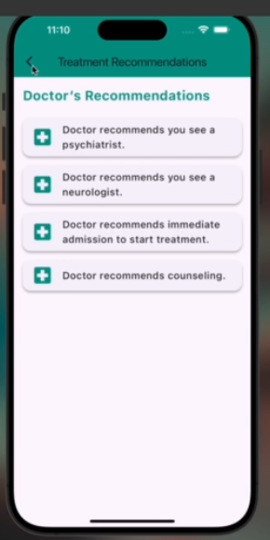

Figure 3.40 – Report recommended treatment

**3.9 Database Integration with Firebase**

In this project, Firebase is the backbone for database integration, enabling seamless storage and retrieval of patient data and user information. The Firebase Realtime Database is used to securely store patient records, including personal details and symptom data. This cloud-hosted NoSQL database allows real-time synchronisation, ensuring that any updates made by the doctor are immediately reflected across all devices connected to the system.

Doctors are registered as users within the system through Firebase Authentication, which securely manages their login credentials. This integration ensures that only authorised medical professionals can access sensitive patient information, maintaining data security and integrity. Firebase's user management capabilities also streamline the process of user onboarding and account management, making it easier for doctors to interact with the system and perform their duties efficiently.

**3.10 Development Tools and Materials**

|  |  |  |  |
| --- | --- | --- | --- |
| Languages | Frameworks | Databases | Extras |
| Python | Flutter | Firebase Realtime Database | Synthetic dataset |
| Dart | Scikit-Learn |  | FASTAPI |
|  |  |  | Render |
|  |  |  | Github |

Table 3.16 – Development Tools And Materials

**3.11 Patient Data protection with HIPAA Compliance**

The security of a cloud-based application is a shared responsibility between the cloud service provider and the customer. In this project, Firebase serves as the primary cloud resource provider, while the machine learning (ML) model is hosted on Render. Both platforms play a critical role in ensuring the security and compliance of the system, particularly in safeguarding sensitive patient data in accordance with the Health Insurance Portability and Accountability Act of 1996 (HIPAA)[19].

**Security of Cloud Resources:** Firebase is responsible for the "security of the cloud," ensuring that the infrastructure hosting its services, including the Realtime Database, is secure. This involves protecting against unauthorised access, ensuring that data is encrypted both at rest and in transit, and maintaining the overall integrity of the platform [20]. Firebase supports HIPAA compliance through its ability to encrypt sensitive data and enforce strong access controls, which are essential for protecting patient information. The Firebase Realtime Database is configured to meet HIPAA requirements by implementing strong encryption methods, ensuring that any data stored within the database is securely protected against breaches [20].

On the other hand, Render, where the ML model is hosted, contributes to the "security in the cloud" by providing a secure environment for running the model and processing patient data. Render ensures that data transmitted to and from the ML model is encrypted using SSL/TLS, which is critical for maintaining data confidentiality during inference. The ML model hosted on Render processes potentially sensitive patient data, and its secure handling is paramount. Render also integrates with existing authentication and authorization mechanisms, such as Firebase Authentication, to ensure that only authorised healthcare professionals can access the model or its outputs.

**HIPAA Compliance and Data Protection:** HIPAA mandates that sensitive patient health information must be protected to prevent unauthorised disclosure [19]. While Firebase ensures that the data storage and access control mechanisms are compliant, the hosting of the ML model on Render must also align with HIPAA standards. Although Render may not be explicitly listed as a HIPAA-compliant service provider, the data flow and security measures implemented in the project, such as encryption and access control, help in maintaining compliance. Additionally, it's important to follow best practices for handling Protected Health Information (PHI) when interacting with the ML model.

**End-to-End Security:** To ensure the end-to-end security of the application, the system incorporates several layers of protection. Firebase Authentication manages user access, ensuring that only authorised users can interact with patient data. Data sent to the ML model on Render is encrypted, and the results, including any generated PDF reports that detail the detected mental health disorders (MHDs) and the doctor’s recommendations, are also encrypted before being stored or shared. This comprehensive approach ensures that sensitive patient data is protected throughout the entire diagnostic process.

In summary, the combined efforts of Firebase and Render contribute to the overall security and compliance of the system. By adhering to HIPAA requirements and implementing strong security controls, the project ensures that all patient data is securely managed, maintaining data integrity and confidentiality across the entire application infrastructure.

**CHAPTER 4 – DESIGN IMPLEMENTATION AND TESTING**

**4.0 Introduction**

This chapter details the final implementation and testing of the entire system. It outlines the tests conducted to assess the system's ability to meet the functional and non-functional requirements specified in Chapter 3. Additionally, this section discusses the results of these tests.

**4.1 The design framework**

The client-side interface of our system was developed using Flutter, paired with the Dart programming language, to create a responsive and user-friendly mobile application. This app serves as the primary tool for healthcare providers to interact with the system, offering seamless functionality. The core of our system's intelligence is a Gradient Boosting Machine model, which was trained and tested using scikit-learn, a Python framework in Google Colab. To ensure real-time functionality, the model was hosted on Render with a FASTAPI server, allowing the mobile app to send HTTP POST requests and receive prediction values instantly.

Additionally, Firebase was integrated into the mobile application to handle user authentication and enhance system security. This combination of Flutter, Dart, and Firebase ensures that the app is both robust and secure, providing healthcare providers with accurate mental health assessments while safeguarding patient data.

**4.2 Design implementation process**   
The design implementation process for the multi-label classification system of mental health disorders followed a structured approach, ensuring that both functional and non-functional requirements were met. This section details the various stages of the implementation process, including data preparation, model development, mobile app integration, and testing.

#### 

#### **1. Data Preparation**

The first step in the implementation process was preparing the dataset for model training and testing. Since the dataset was synthetically generated, it was crucial to ensure that it reflected real-world conditions. Gaussian noise, with a mean of 0 and a standard deviation of 0.1, was added to the data to introduce variance and simulate the inconsistencies typically seen in real-world user data.

#### **2. Model Development**

The machine learning model was developed using a Gradient Boosting Machine (GBM) algorithm. This model was selected due to its high accuracy in handling multi-label classification problems and its ability to reduce both bias and variance through iterative boosting. The GBM model was trained to classify multiple mental health disorders based on the input features obtained from user data. The model was fine-tuned through hyperparameter optimization, with key parameters such as the learning rate of 0.01, number of estimators of 200, and maximum tree depth of 7 to achieve the best possible model performance.

The model's output consisted of binary predictions for each disorder (indicating whether the user is likely to have that disorder) and corresponding probability scores to reflect the confidence of each prediction. These outputs were structured in a JSON format and exposed through a FastAPI endpoint for easy integration with the mobile application.

#### **3. Server-Side Integration**

The server-side architecture was implemented using **FastAPI** to expose the model and handle requests from the mobile application. The key component was the /classify endpoint, which accepted user data from the app, processed it, passed it through the model, and returned the classification results. The server was designed to ensure low-latency response times, making it capable of real-time interaction with the mobile app.

Data security was a primary concern due to the sensitive nature of mental health data. **Firebase** was used to store user data securely, with all communications between the server and app encrypted using SSL/TLS. Firebase Authentication was integrated to restrict access to authorized users.

#### **4. Mobile Application Integration**

The mobile app acted as the user interface for data collection and presenting classification results. It was built using Flutter to ensure cross-platform compatibility. The app collected user responses through surveys and assessments, which were then sent to the backend server for classification. Once the results were returned, the app displayed the predicted mental health disorders along with the associated probabilities in a user-friendly format. The app also provided treatment recommendations based on the classification results.

#### **5. Testing and Validation**

The final phase of the implementation process involved testing the system for both functional correctness and performance. The model was evaluated using standard performance metrics such as accuracy, precision, recall, and F1-score, ensuring that it provided reliable classifications. Additionally, the system was tested for scalability by simulating increasing numbers of users and ensuring the backend could handle the load without affecting response times.

User acceptance testing (UAT) was conducted with sample dummy data by our medic collaborator to evaluate the accuracy of the classification system in providing meaningful insights into mental health conditions. The feedback from this testing phase was used to make final adjustments before deployment.

**4.3 Testing of design and results**

Our medic collaborator from Korle Bu Hospital conducted two blind tests on the system. The first blind test was conducted on a Streamlit [21] web app with an earlier model and the second blind test on a mobile phone with the finalised model.

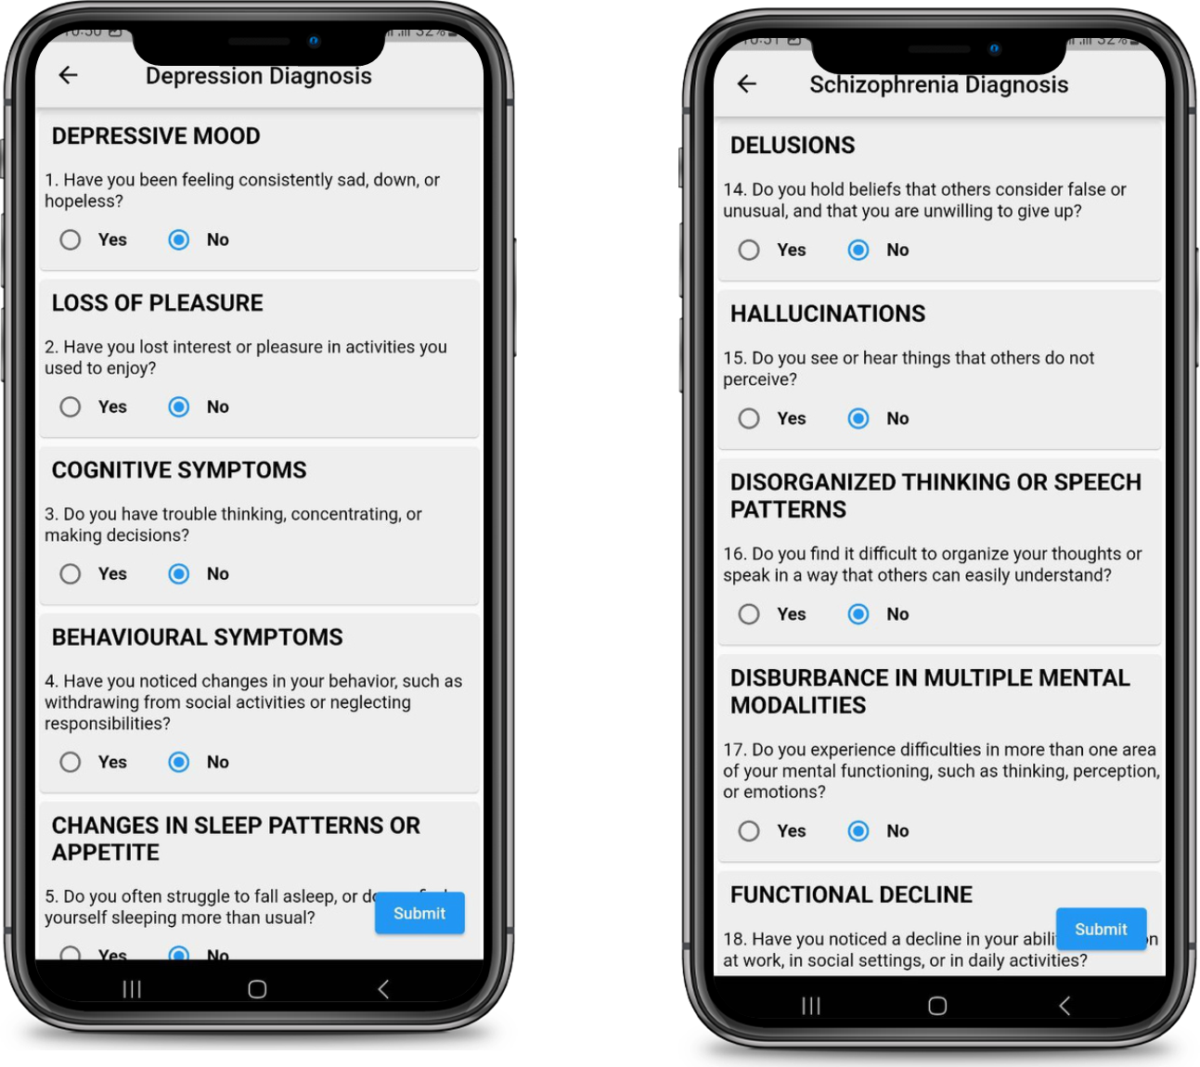

Figure 4.0 – Recording symptoms to be sent to the model for classification

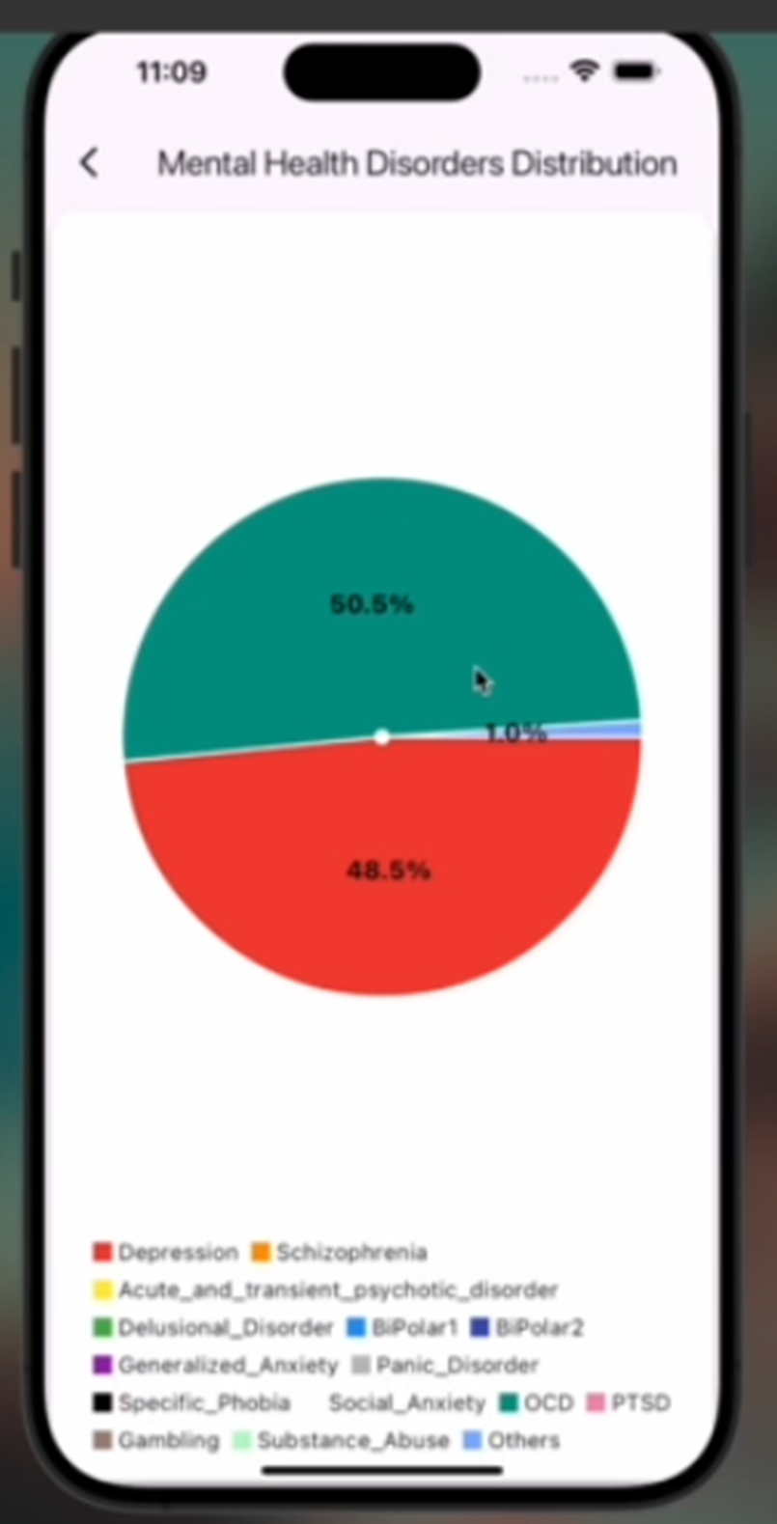

Figure 4.1 - Results from 2nd blind test by clinical psychiatrist

**4.4 Discussion of results and analysis**

Synthetic Data Test Results

Table 4.1 - Summary of test results for synthetic data tests

|  |  |  |  |
| --- | --- | --- | --- |
| No. | Expected Diagnosis | Predicted Diagnosis | Remarks |
| 1 | Schizophrenia with Depression | Depression: 95.7 %  Schizophrenia: 94.6%  Acute and transient psychotic disorder:10%  Delusional Disorder:0%  Bipolar1: 0 %  Bipolar2: 0%  Generalized Anxiety: 1.5 %  Panic Disorder:0%  Specific Phobia: 0%  Social Anxiety: 0%  OCD: 0%  PTSD: 0%  Gambling Disorder: 0%  Substance Use: 12%  Others: 0% | Sample classified as expected |
| 2 | Delusional Disorder | Depression: 0 %  Schizophrenia: 2%  Acute and transient psychotic disorder:1%  Delusional Disorder:99.7%  Bipolar1: 0 %  Bipolar2: 0%  Generalized Anxiety: 3 %  Panic Disorder:0%  Specific Phobia: 0%  Social Anxiety: 0%  OCD: 4%  PTSD: 0%  Gambling Disorder: 0%  Substance Use: 0%  Others: 0% | Sample classified as expected |
| 3 | Depression with Substance Use | Depression: 64 %  Schizophrenia: 1%  Acute and transient psychotic disorder:1%  Delusional Disorder:0%  Bipolar1: 0 %  Bipolar2: 0%  Generalized Anxiety: 2 %  Panic Disorder:0%  Specific Phobia: 0%  Social Anxiety: 0%  OCD: 0%  PTSD: 0%  Gambling Disorder: 0%  Substance Use: 92%  Others: 5% | Confidence level of Depression below the 90% standard threshold. Classification acceptable but not adequate for proper conclusion |

Blind Test Results

Table 4.2 - Summary of results for blind test

|  |  |  |  |
| --- | --- | --- | --- |
| No | Expected Diagnosis | Predicted Diagnosis | Remarks |
| 1 | Depression | Depression: 89.0%  Schizophrenia: 0%  Acute and transient psychotic disorder: 1%  Delusional Disorder: 0%  Bipolar1: 2 %  Bipolar2: 0%  Generalized Anxiety: 2 %  Panic Disorder: 0%  Specific Phobia: 3.2%  Social Anxiety: 0%  OCD: 0%  PTSD: 0.3%  Gambling Disorder: 0%  Substance Use: 0%  Others: 2% | **Depression Identified successfully.** |
| 2 | OCD & Depression | Depression: 96.0%  Schizophrenia: 3.2%  Acute and transient psychotic disorder: 10%  Delusional Disorder: 0%  Bipolar1: 0 %  Bipolar2: 0%  Generalized Anxiety: 1.5 %  Panic Disorder: 0%  Specific Phobia: 0%  Social Anxiety: 0%  OCD: 100.0%  PTSD: 0%  Gambling Disorder: 0%  Substance Use: 12%  Others: 0% | **Predicted both Depression and OCD with high accuracy.** |

**4.5 Limitations and constraints**   
  
Despite the successes and innovations presented in this project, several limitations and constraints were encountered during development. These limitations are important to recognize, as they influence the scope, generalizability, and future improvements of the project.

#### **1. Limited Real-World Data**

The project relies on synthetically generated data due to the difficulty of obtaining a large, labelled dataset for mental health disorders. While synthetic data was augmented with Gaussian noise to simulate variability, it may not fully capture the complexity, diversity, and subtle nuances found in real-world mental health data. This could affect the model's ability to generalise well when applied to actual patient data from various demographics and environments. [22]

#### **2. Scalability and Performance**

As the number of users grows, server performance and scalability become increasingly critical. The current system architecture, while designed to handle multiple requests, has not been stress-tested for very large user bases. There may be limitations in the server's ability to process large amounts of data in real-time, particularly when faced with heavy loads or when multiple concurrent users are accessing the classification system.  
  
**3. Dependency on Internet Connectivity**

The mobile application is dependent on internet connectivity to communicate with the backend server and retrieve classification results. This limits the system’s functionality in regions with poor or no internet access. Users without reliable internet connections may experience delays or inability to access the classification system, limiting the app’s accessibility.

**4. Limited Clinical Validation**

While the system is designed to provide insights into mental health disorders, it has not undergone extensive clinical validation. The predictions made by the model are based on data patterns and not on clinical diagnosis. This system is intended to serve as a supplementary tool and should not replace medical professionals in diagnosing or treating mental health conditions. Further collaboration with mental health professionals would be required to validate the model’s predictions in real-world clinical settings

**CHAPTER 5 – CONCLUSION**

**5.1 Introduction**

The aim of this project was to develop and implement a mobile application that leverages machine learning models, including AdaBoost Classifier, Gradient Boosting Machines (GBMs), K-Nearest Neighbours (KNN), and Support Vector Machines (SVMs), to detect and classify various mental health disorders. This chapter evaluates the system based on the project's objectives, summarising key findings and challenges encountered during the development and testing phases. Recommendations for future improvements are also provided.

**5.2 Conclusion**

**The primary objectives of this project were:**

1. To identify key features for the classification of the 14 mental health disorders (MHDs) within the scope of the project, using standardised diagnostic criteria from ICD-11 and DSM-5.

2. To develop, train, and implement machine learning models that could accurately detect and classify the specified MHDs based on binary patient input.

3. To design and develop a mobile application using Flutter and Dart, providing a user-friendly interface for data acquisition, symptom tracking, and integration with the machine learning models for diagnostic support.

4. To integrate Firebase for secure user authentication and storage of patient data, ensuring the system adheres to relevant data protection standards.

The overall goals of the project were successfully achieved through the design and implementation process described in Chapter 3 and Chapter 4. The system has the potential to reduce the burden on mental health professionals by aiding in the early detection of mental health disorders. With the system in place, primary healthcare workers can perform initial diagnoses, allowing for more efficient use of specialist resources. Additionally, the system can serve as a learning tool for general healthcare providers, enhancing their ability to identify and manage mental health disorders, severities and their comorbidities.

**5.3 Contribution to Knowledge and Society**

Our project bridges advanced research in mental health diagnostics with practical, real-world applications.

By integrating machine learning into mental health diagnostics, the project not only contributes to academic knowledge but also directly addresses societal challenges. It advances understanding in the field of psychiatry by enhancing diagnostic accuracy, especially in the detection of comorbid mental health conditions. This contributes to the broader knowledge of mental health diagnostics by offering a systematic, data-driven approach that can improve clinical outcomes.

At the same time, the societal impact is profound. In areas where mental health services are scarce, particularly in low-resource regions, the project offers an accessible and scalable solution for early detection. By providing general practitioners and healthcare providers with a reliable tool to screen for mental health disorders, it helps mitigate the shortage of psychiatrists and improves patient care.

Ultimately, this project serves as a critical link between academic advancements and societal well-being, ensuring that the benefits of cutting-edge research are felt by those who need it most.

**5.4 Observations and Challenges**

One of the key challenges encountered during the project was the reliance on binary data inputs ("yes" or "no" responses) for the classification of mental health disorders. While this streamlined the diagnostic process, it limited the flexibility to capture more complex patient responses. Additionally, the absence of real clinical data posed a challenge to testing the model's performance in real-world settings. Obtaining access to comprehensive and high-quality clinical datasets in future research would be beneficial to further enhance the accuracy and robustness of the system. [23]

**5.5 Recommendations**

While this project successfully addressed 14 key mental health disorders, future work could expand the system to include additional conditions, especially those not covered by the current scope. Furthermore, the binary data acquisition approach limits the depth of patient responses. Future versions of the system could explore incorporating more nuanced data inputs to capture a broader range of symptoms.

Additionally, future iterations should aim to include the ability to assess the severity of mental health disorders, which was beyond the scope of this project. Introducing a feature to track symptom progression could also provide better long-term care and enable early intervention when necessary. Finally, collaborating with medical professionals to validate the model on real-world clinical data and ensuring ethical clearance for handling sensitive patient information are essential steps toward optimising the system for real-world hospital use.

**References**

[1] C.D. Williams and A. Kidder, "A mental disorder is defined as a syndrome that involves a clinically significant disruption in an individual's cognition." in Encyclopedia of Mental Health (Second Edition), 2016.

[2] World Health Organization, “Depression and Other Common Mental Disorders: Global Health Estimates,” WHO, 2017. [Online]. Available:[https://apps.who.int/iris/bitstream/handle/10665/254610/WHO-MSD-MER-2017.2-eng.pd](https://apps.who.int/iris/bitstream/handle/10665/254610/WHO-MSD-MER-2017.2-eng.pdf)f

[3] Institute for Health Metrics and Evaluation, “COVID-19 pandemic led to stark rise in depressive and anxiety disorders globally in 2020, with women and younger people most affected,” The Lancet, Oct. 2021. [Online]. Available: <https://www.healthdata.org>

[4]- World Health Organization. (2022). Mental health: [“Ghana has only 39 psychiatrists](https://www.bing.com/ck/a?!&&p=dfb634452cef8ee6JmltdHM9MTcyNDgwMzIwMCZpZ3VpZD0xOGIwMzUxNC1lNDY1LTYzNTMtMmZkNC0yNjU4ZTUwNzYyM2QmaW5zaWQ9NTcyMA&ptn=3&ver=2&hsh=3&fclid=18b03514-e465-6353-2fd4-2658e507623d&psq=how+many+psychiatrists+in+the+ghana&u=a1aHR0cHM6Ly93d3cuYWZyby53aG8uaW50L2NvdW50cmllcy9naGFuYS9uZXdzL2ltcHJvdmluZy1hY2Nlc3MtbWVudGFsLWhlYWx0aC1zZXJ2aWNlcy1naGFuYQ&ntb=1).” Available: [https://www.who.int/data/gho/data/themes/theme-details/GHO/mental-health](https://www.afro.who.int/countries/ghana/news/improving-access-mental-health-services-ghana)

[5] - E. Asiedu and E.M. DUMENU. DETECTION AND CLASSIFICATION OF MENTAL HEALTH DISORDERS USING MACHINE LEARNING (2021),.

[6] P. Singh, G. Singh, S. Bharti "The Predictive Model of Mental Illness using Decision Tree and Random Forest Classification in Machine Learning,"

**[7].** K.Vaishnavi, U.N.Kamath, B.A.Rao and N.V.S.Reddy "Predicting Mental Health Illness using Machine Learning Algorithms,", Journal of physics: conference series, doi:10.1088/1742-6596/2161/1/012021

**[8]** P. Yadav, S. Shinde, and R. Shedge, "Mental Health Disorder Detection using Machine Learning and Deep Learning Techniques," in *2023 3rd Asian Conference on Innovation in Technology (ASIANCON)*, Pune, India, Aug. 2023, pp. 1-6.

**[9]** J. Chung and J. Teo, "Mental Health Prediction Using Machine Learning: Taxonomy, Applications, and Challenges," *Applied Computational Intelligence and Soft Computing*, vol. 2022, Art. no. 9970363, pp. 1-19, Jan. 2022, doi: 10.1155/2022/9970363.

[10] B. Shickel, S. Siegel, M. Heesacker, S. Benton, and P. Rashidi, "Automatic Detection and Classification of Cognitive Distortions in Mental Health Text," in *2020 IEEE 20th International Conference on Bioinformatics and Bioengineering (BIBE)*, 2020, pp. 521-526, doi: 10.1109/BIBE50027.2020.00052.

[11] R. A. Rahman, K. Omar, S. A. M. Noah, M. S. N. M. Danuri, and M. A. Al-Garadi, q"Application of Machine Learning Methods in Mental Health Detection: A Systematic Review," *IEEE Access*, vol. 8, pp. 183952-183966, Oct. 2020, doi: 10.1109/ACCESS.2020.3029154.

[12] - A. Géron, *Hands-on Machine Learning with Scikit-Learn, Keras, and TensorFlow*, 2nd ed. Sebastopol, CA, USA: O'Reilly Media, 2019.

[13] - J. Brownlee, "What is Machine Learning? A definition," *Machine Learning Mastery*, Aug. 15, 2020. [Online]. Available: <https://machinelearningmastery.com/what-is-machine-learning/>.

[14] - F. Chollet, *Deep Learning with Python*, 1st ed. Shelter Island, NY, USA: Manning, 2018.

[15] - World Health Organization, *International Classification of Diseases, 11th Revision (ICD-11)*, 2019. [Online]. Available: [https://icd.who.int](https://icd.who.int/)

[16] - A. Krizhevsky, I. Sutskever, and G. E. Hinton, "ImageNet classification with deep convolutional neural networks," in *Proc. Advances in Neural Information Processing Systems (NeurIPS)*, 2012, pp. 1097–1105.

[17] - T. Mitchell, *Machine Learning*, New York, NY, USA: McGraw-Hill, 1997.

[18] - How To Make Gaussian Noise. Available: https://epochabuse.com/gaussian-noise/

[19] Health Insurance Portability and Accountability Act of 1996 (HIPAA). U.S. Department of Health & Human Services: https://www.hhs.gov/hipaa/index.html

[20] Firebase Realtime Database Security. Firebase Documentation: https://firebase.google.com/docs/database/security

[21] Streamlit Official Website Available : [https://streamlit.i](https://streamlit.io/)o/

[22] M. A. Abdar, F. Nazerfard, and T. Safavian, "Synthetic data generation for healthcare applications: Challenges and opportunities," IEEE Access, vol. 8, pp. 11759–11771, 2020. [Online]. Available: https://doi.org/10.1109/ACCESS.2020.2967264

[23] J. M. Hernández-García and F. Gómez-Rodríguez, "Challenges of machine learning applications in clinical data," Journal of Healthcare Informatics Research, vol. 4, no. 3, pp. 245–257, 2020. [Online]. Available: https://doi.org/10.1007/s41666-020-00054-2

**Appendices**

5.6 APPENDIX A – Source Code for Server Side

User Registration Code

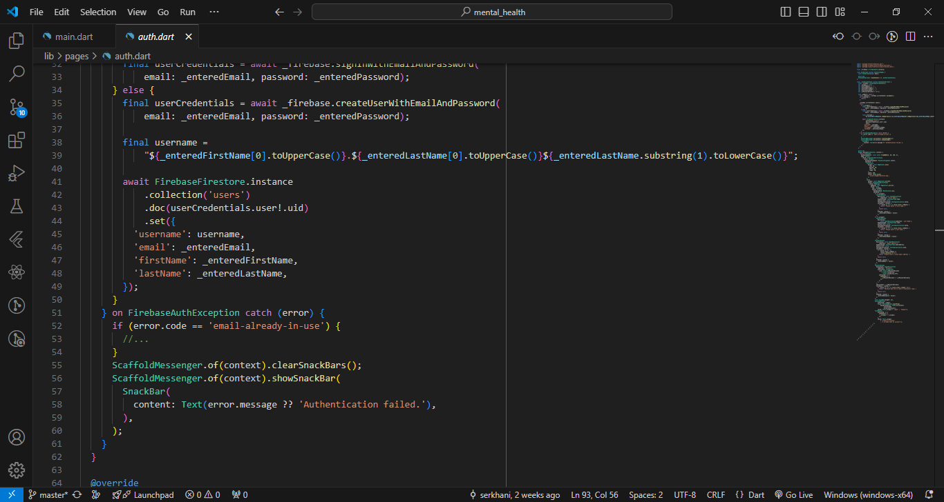

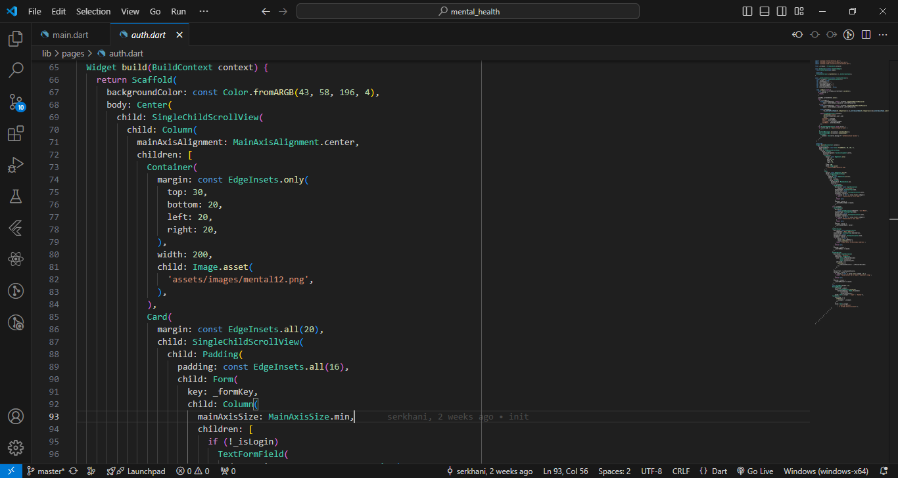

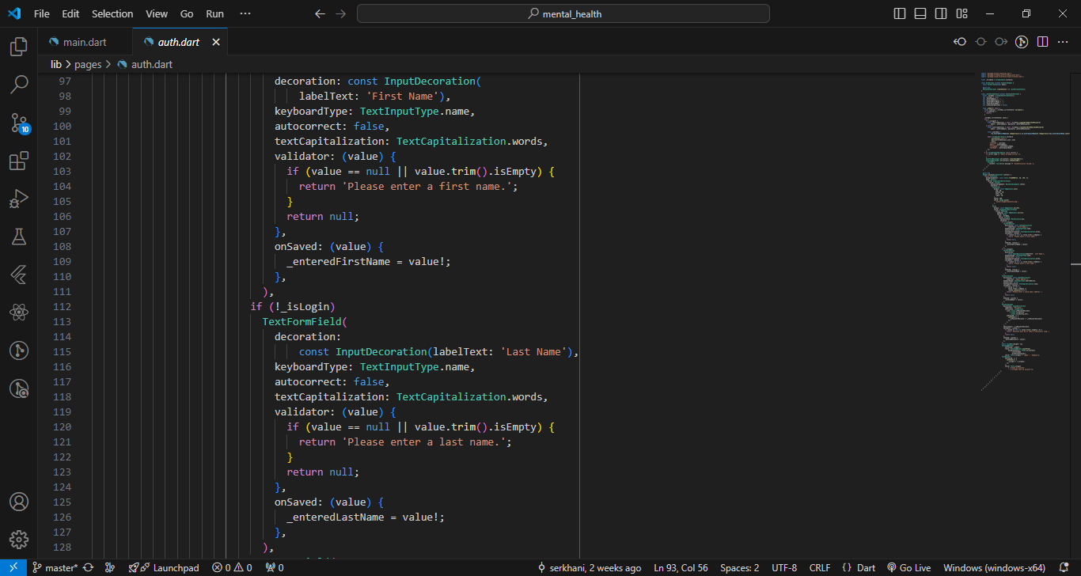

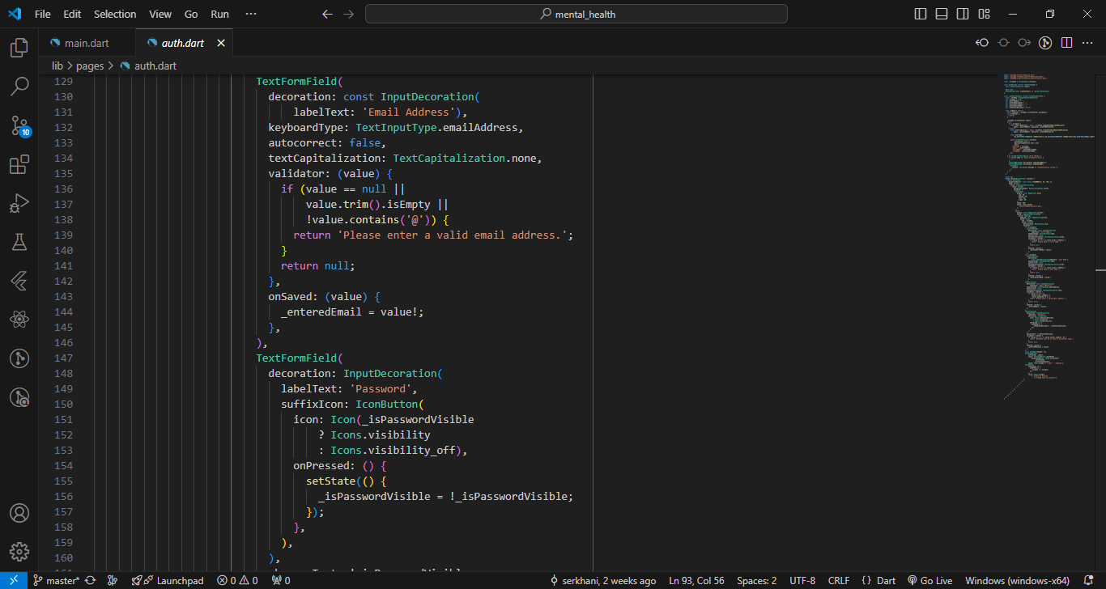

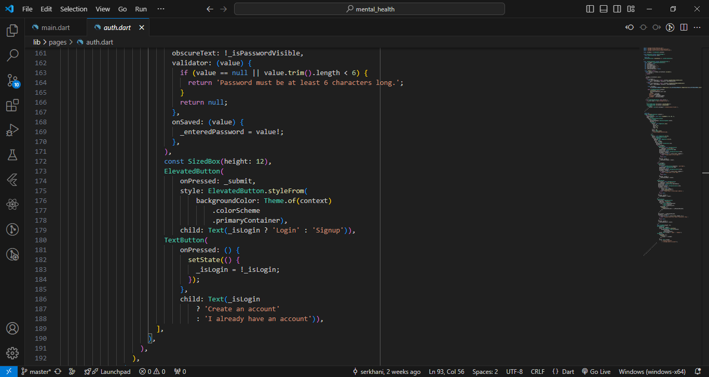

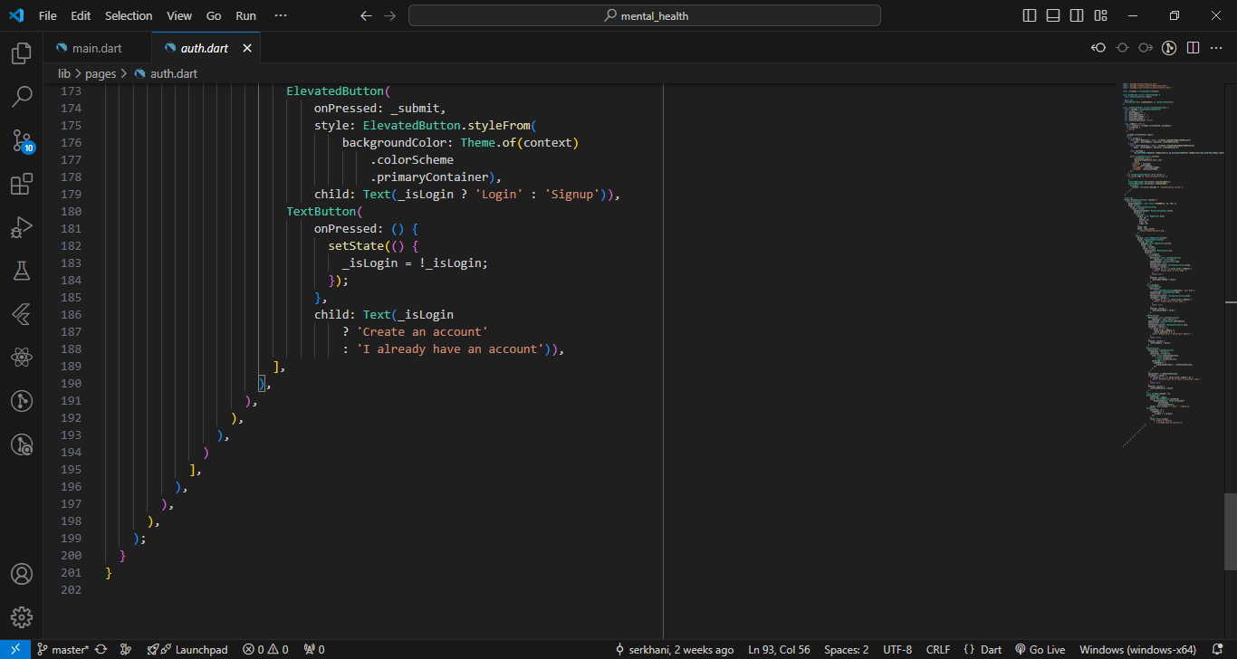

Add Patient Functionality

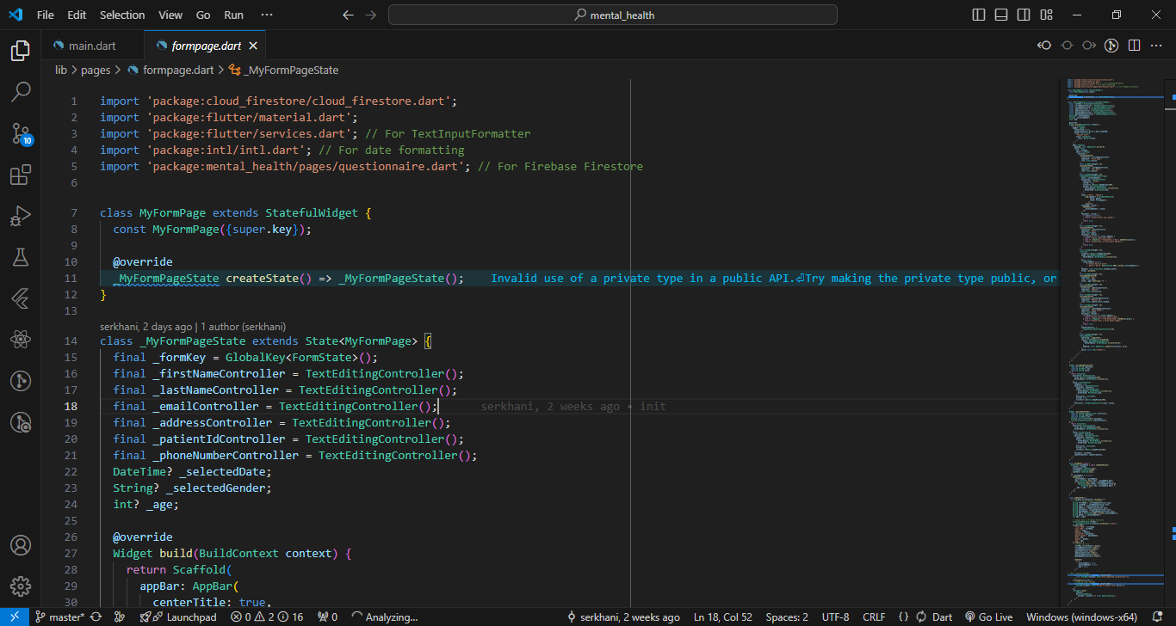

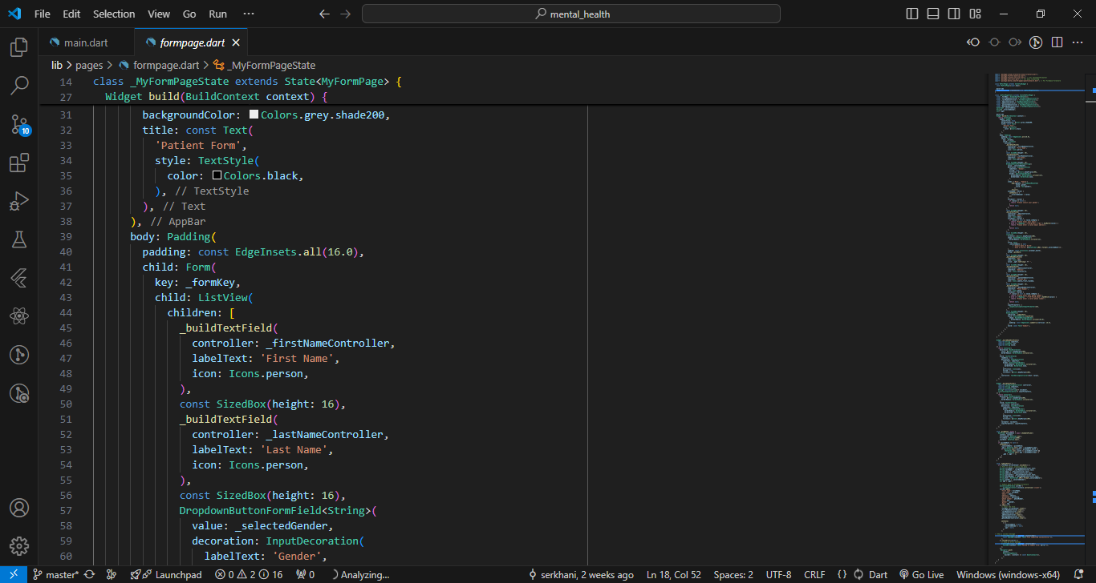

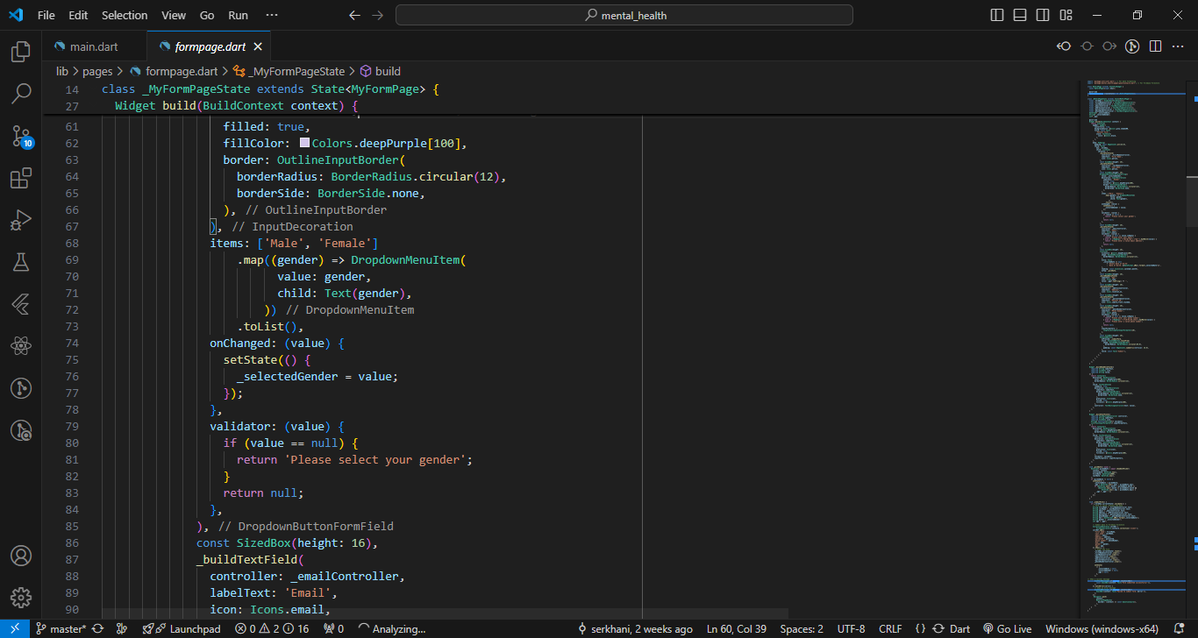

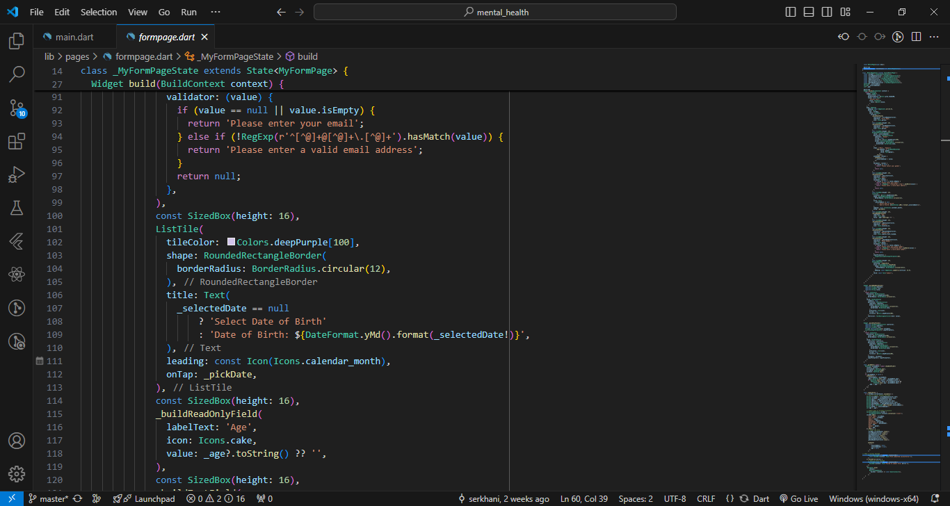

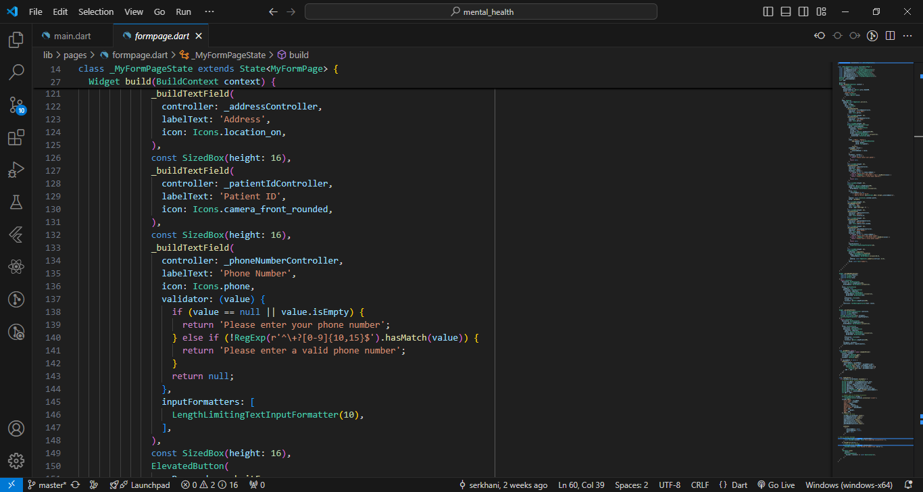

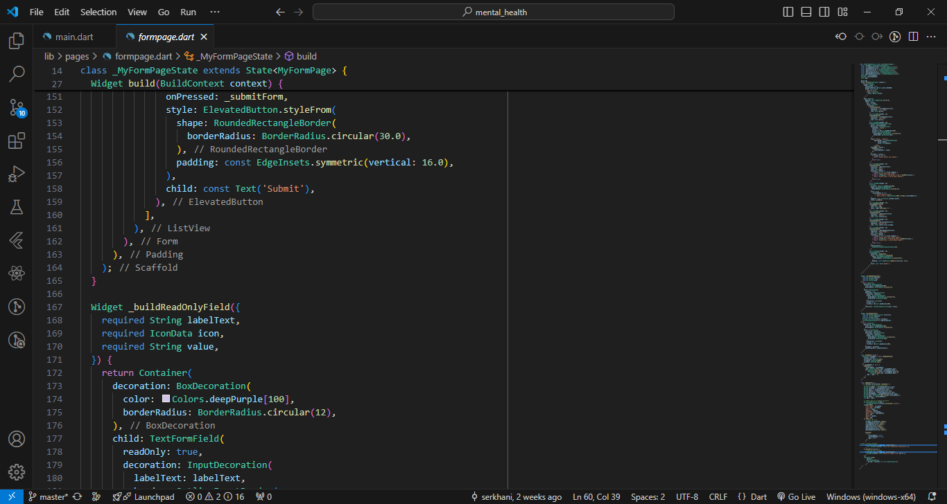

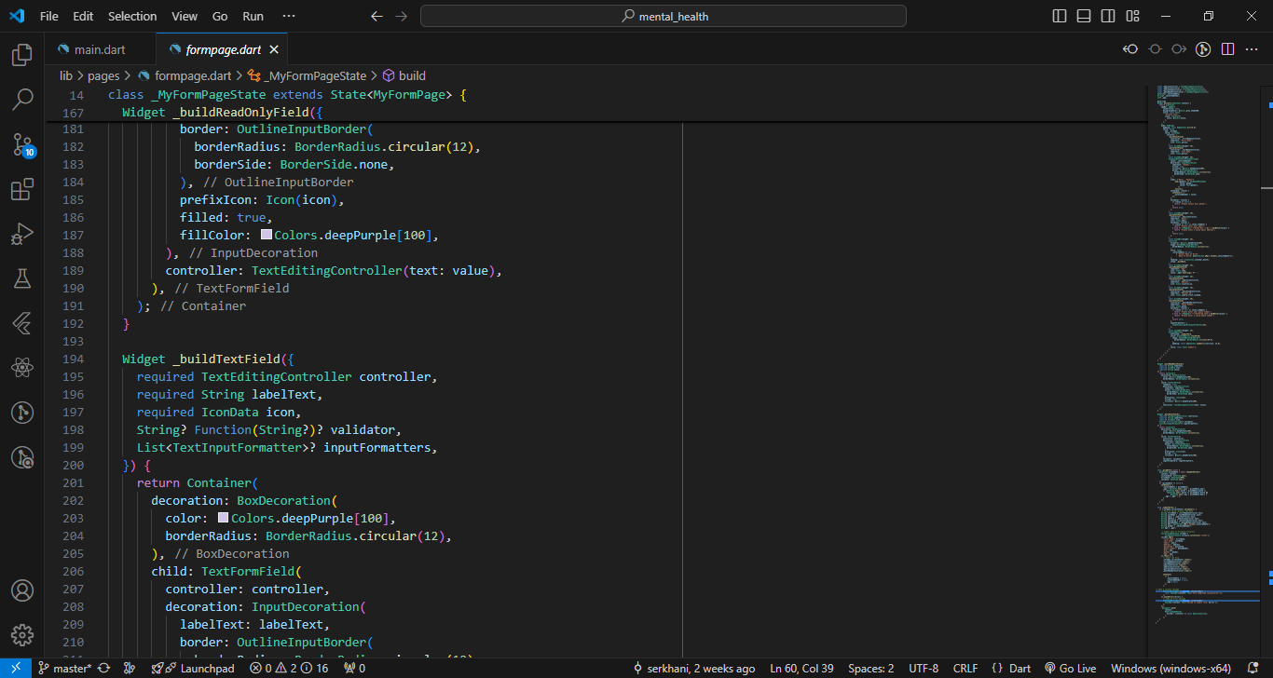

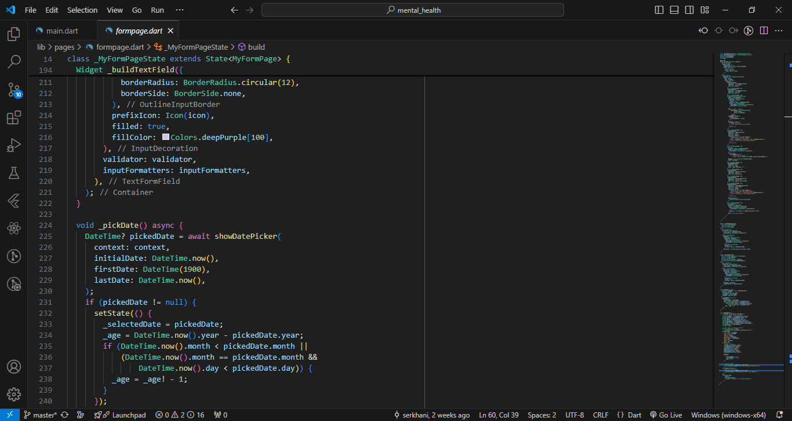

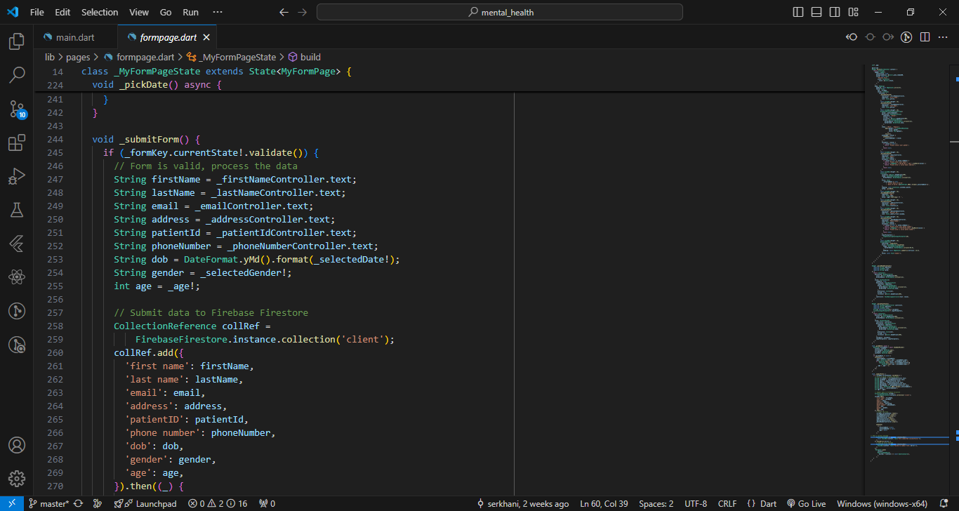

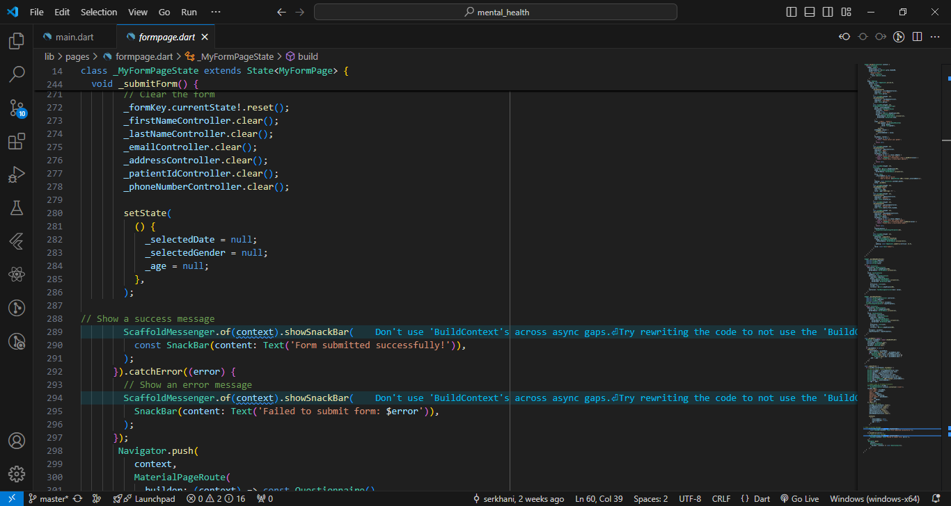

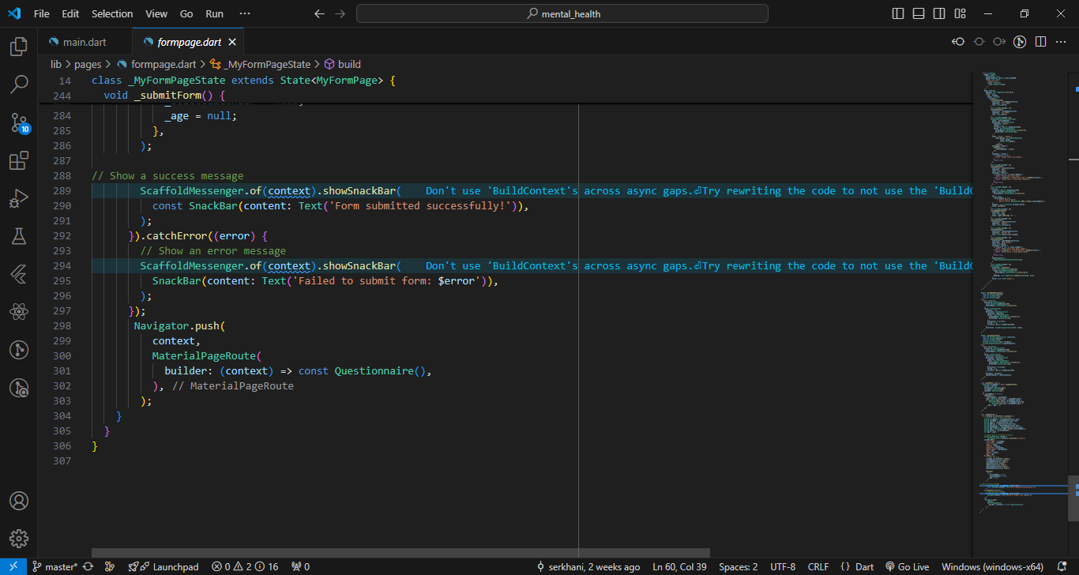

5.7 APPENDIX B - Machine Learning Model Development

